

ProjectX

Test Report

Test Session Summary

|  |  |
| --- | --- |
| Start: Mon Apr 13 07:40:10 2020 End: Mon Apr 13 07:51:45 2020 Duration: 0:11:34.871000  broken: 4 (7.27%) failed: 6 (10.91%) skipped: 0 (0.00%) passed: 45 (81.82%) |  |

Test Results

# Liked Songs Play Button with empty playlist - broken

Testing Your Library Liked Songs Play Button with empty playlist

## Details

AttributeError: 'NoneType' object has no attribute 'click'

|  |
| --- |
| self = <Web_Testing.Tests.test_yourLibrary.TestWebPlayerLibrary object at 0x1109ac850> setup_final = None   @allure.severity(allure.severity_level.BLOCKER)  @allure.story("Testing Your Library Liked Songs Play Button with empty playlist")  @allure.title("Liked Songs Play Button with empty playlist")  @allure.description("Testing Your Library Liked Songs Play Button with empty playlist")  @pytest.mark.Do  @pytest.mark.YourLibrary  def test_case_4(self, setup_final):  web_player_home = WebPlayerHome(self.driver)  web_player_home.click_logout()  time.sleep(2)  web_player_home.click_login()  time.sleep(3)  lp = LoginPage(self.driver)  lp.login_to_spotify("abdallah@gmail.com", "123456")  time.sleep(3)  self.driver.get(self.helper.base_url + "webplayer/home")  time.sleep(3)  web_player_home = WebPlayerHome(self.driver) > web_player_home.click_your_library()  Web_Testing/Tests/test_yourLibrary.py:138:  _ _ _ _ _ _ _ _ _ _ _ _ _ _ _ _ _ _ _ _ _ _ _ _ _ _ _ _ _ _ _ _ _ _ _ _ _ _ _ _   self = <Web_Testing.Pages.WebPlayerHome.WebPlayerHome object at 0x1109b05b0>   def click_your_library(self):  """  Clicks Your Library button in web player menu  """ > (self.find_element_by_xpath("/html/body/div/div/div/div/div[1]/div/div/div[1]/div/button")).click() E AttributeError: 'NoneType' object has no attribute 'click'  Web_Testing/Pages/WebPlayerMenu.py:96: AttributeError |

## Test Setup

[Fixture] setup_final

## Test Body

[Attachment] stdout

## Test Teardown

[Fixture] setup_final::0

# Playlist Play Button - broken

Testing Playlist Play Button

## Details

AttributeError: 'NoneType' object has no attribute 'click'

|  |
| --- |
| self = <Web_Testing.Tests.test_playlist.TestPlaylist object at 0x10b291cd0> setup_initial = None   @allure.severity(allure.severity_level.BLOCKER)  @allure.story("Testing Play Button")  @allure.title("Playlist Play Button")  @allure.description("Testing Playlist Play Button")  @pytest.mark.Do  @pytest.mark.YourLibrary  def test_case_1(self, setup_initial):  time.sleep(3)  lp = LoginPage(self.driver)  lp.login_to_spotify("abdallah@gmail.com", "123456")  time.sleep(3)  self.driver.get(self.helper.base_url + "webplayer/home")  time.sleep(3)  web_player_home = WebPlayerHome(self.driver) > web_player_home.click_your_library()  Web_Testing/Tests/test_playlist.py:81:  _ _ _ _ _ _ _ _ _ _ _ _ _ _ _ _ _ _ _ _ _ _ _ _ _ _ _ _ _ _ _ _ _ _ _ _ _ _ _ _   self = <Web_Testing.Pages.WebPlayerHome.WebPlayerHome object at 0x10b304430>   def click_your_library(self):  """  Clicks Your Library button in web player menu  """ > (self.find_element_by_xpath("/html/body/div/div/div/div/div[1]/div/div/div[1]/div/button")).click() E AttributeError: 'NoneType' object has no attribute 'click'  Web_Testing/Pages/WebPlayerMenu.py:96: AttributeError |

## Test Setup

[Fixture] setup_initial

## Test Body

[Attachment] stdout

## Test Teardown

[Fixture] setup_initial::0

# artist follow Button - broken

Testing artist follow Button

## Details

AttributeError: 'NoneType' object has no attribute 'click'

|  |
| --- |
| self = <Web_Testing.Tests.test_artist.TestPlaylist object at 0x10c948880> setup_final = None   @allure.severity(allure.severity_level.BLOCKER)  @allure.story("Testing follow Button")  @allure.title("artist follow Button")  @allure.description("Testing artist follow Button")  @pytest.mark.Do  @pytest.mark.YourLibrary  def test_case_2(self, setup_final):  time.sleep(3)  lp = LoginPage(self.driver)  lp.login_to_spotify("abdallah@gmail.com", "123456")  time.sleep(3)  self.driver.get(self.helper.base_url + "webplayer/home")  time.sleep(3)  web_player_home = WebPlayerHome(self.driver) > web_player_home.click_your_library()  Web_Testing/Tests/test_artist.py:109:  _ _ _ _ _ _ _ _ _ _ _ _ _ _ _ _ _ _ _ _ _ _ _ _ _ _ _ _ _ _ _ _ _ _ _ _ _ _ _ _   self = <Web_Testing.Pages.WebPlayerHome.WebPlayerHome object at 0x10c985940>   def click_your_library(self):  """  Clicks Your Library button in web player menu  """ > (self.find_element_by_xpath("/html/body/div/div/div/div/div[1]/div/div/div[1]/div/button")).click() E AttributeError: 'NoneType' object has no attribute 'click'  Web_Testing/Pages/WebPlayerMenu.py:96: AttributeError |

## Test Setup

[Fixture] setup_final

## Test Body

No test body information available.

## Test Teardown

[Fixture] setup_final::0

# change to premium account - broken

change to premium account

## Details

SystemExit: Testing failed to make claim premium

|  |
| --- |
| self = <Web_Testing.Pages.premium.PremiumPage object at 0x106612070>   def check_claim_premium(self):  try:  self.click_get_premium_button_1() > alert = self.driver.switch_to.alert  Web_Testing/Pages/premium.py:164:  _ _ _ _ _ _ _ _ _ _ _ _ _ _ _ _ _ _ _ _ _ _ _ _ _ _ _ _ _ _ _ _ _ _ _ _ _ _ _ _   self = <selenium.webdriver.remote.switch_to.SwitchTo object at 0x1066125b0>   @property  def alert(self):  """  Switches focus to an alert on the page.    :Usage:  alert = driver.switch_to.alert  """  alert = Alert(self._driver) > alert.text  venv/lib/python3.8/site-packages/selenium/webdriver/remote/switch_to.py:55:  _ _ _ _ _ _ _ _ _ _ _ _ _ _ _ _ _ _ _ _ _ _ _ _ _ _ _ _ _ _ _ _ _ _ _ _ _ _ _ _   self = <selenium.webdriver.common.alert.Alert object at 0x1079ac1c0>   @property  def text(self):  """  Gets the text of the Alert.  """  if self.driver.w3c: > return self.driver.execute(Command.W3C_GET_ALERT_TEXT)["value"]  venv/lib/python3.8/site-packages/selenium/webdriver/common/alert.py:67:  _ _ _ _ _ _ _ _ _ _ _ _ _ _ _ _ _ _ _ _ _ _ _ _ _ _ _ _ _ _ _ _ _ _ _ _ _ _ _ _   self = <selenium.webdriver.chrome.webdriver.WebDriver (session="4e6ead03b8937527e4f2d10241e39a89")> driver_command = 'w3cGetAlertText', params = {}   def execute(self, driver_command, params=None):  """  Sends a command to be executed by a command.CommandExecutor.    :Args:  - driver_command: The name of the command to execute as a string.  - params: A dictionary of named parameters to send with the command.    :Returns:  The command's JSON response loaded into a dictionary object.  """  if self.session_id is not None:  if not params:  params = {'sessionId': self.session_id}  elif 'sessionId' not in params:  params['sessionId'] = self.session_id    params = self._wrap_value(params)  response = self.command_executor.execute(driver_command, params)  if response: > self.error_handler.check_response(response)  venv/lib/python3.8/site-packages/selenium/webdriver/remote/webdriver.py:321:  _ _ _ _ _ _ _ _ _ _ _ _ _ _ _ _ _ _ _ _ _ _ _ _ _ _ _ _ _ _ _ _ _ _ _ _ _ _ _ _   self = <selenium.webdriver.remote.errorhandler.ErrorHandler object at 0x10792a1f0> response = {'status': 404, 'value': '{"value":{"error":"no such alert","message":"no such alert\\n (Session info: chrome=80.0.39...fff73025e65 _pthread_start + 148\\n19 libsystem_pthread.dylib 0x00007fff7302183b thread_start + 15\\n"}}'}   def check_response(self, response):  """  Checks that a JSON response from the WebDriver does not have an error.    :Args:  - response - The JSON response from the WebDriver server as a dictionary  object.    :Raises: If the response contains an error message.  """  status = response.get('status', None)  if status is None or status == ErrorCode.SUCCESS:  return  value = None  message = response.get("message", "")  screen = response.get("screen", "")  stacktrace = None  if isinstance(status, int):  value_json = response.get('value', None)  if value_json and isinstance(value_json, basestring):  import json  try:  value = json.loads(value_json)  if len(value.keys()) == 1:  value = value['value']  status = value.get('error', None)  if status is None:  status = value["status"]  message = value["value"]  if not isinstance(message, basestring):  value = message  message = message.get('message')  else:  message = value.get('message', None)  except ValueError:  pass    exception_class = ErrorInResponseException  if status in ErrorCode.NO_SUCH_ELEMENT:  exception_class = NoSuchElementException  elif status in ErrorCode.NO_SUCH_FRAME:  exception_class = NoSuchFrameException  elif status in ErrorCode.NO_SUCH_WINDOW:  exception_class = NoSuchWindowException  elif status in ErrorCode.STALE_ELEMENT_REFERENCE:  exception_class = StaleElementReferenceException  elif status in ErrorCode.ELEMENT_NOT_VISIBLE:  exception_class = ElementNotVisibleException  elif status in ErrorCode.INVALID_ELEMENT_STATE:  exception_class = InvalidElementStateException  elif status in ErrorCode.INVALID_SELECTOR \  or status in ErrorCode.INVALID_XPATH_SELECTOR \  or status in ErrorCode.INVALID_XPATH_SELECTOR_RETURN_TYPER:  exception_class = InvalidSelectorException  elif status in ErrorCode.ELEMENT_IS_NOT_SELECTABLE:  exception_class = ElementNotSelectableException  elif status in ErrorCode.ELEMENT_NOT_INTERACTABLE:  exception_class = ElementNotInteractableException  elif status in ErrorCode.INVALID_COOKIE_DOMAIN:  exception_class = InvalidCookieDomainException  elif status in ErrorCode.UNABLE_TO_SET_COOKIE:  exception_class = UnableToSetCookieException  elif status in ErrorCode.TIMEOUT:  exception_class = TimeoutException  elif status in ErrorCode.SCRIPT_TIMEOUT:  exception_class = TimeoutException  elif status in ErrorCode.UNKNOWN_ERROR:  exception_class = WebDriverException  elif status in ErrorCode.UNEXPECTED_ALERT_OPEN:  exception_class = UnexpectedAlertPresentException  elif status in ErrorCode.NO_ALERT_OPEN:  exception_class = NoAlertPresentException  elif status in ErrorCode.IME_NOT_AVAILABLE:  exception_class = ImeNotAvailableException  elif status in ErrorCode.IME_ENGINE_ACTIVATION_FAILED:  exception_class = ImeActivationFailedException  elif status in ErrorCode.MOVE_TARGET_OUT_OF_BOUNDS:  exception_class = MoveTargetOutOfBoundsException  elif status in ErrorCode.JAVASCRIPT_ERROR:  exception_class = JavascriptException  elif status in ErrorCode.SESSION_NOT_CREATED:  exception_class = SessionNotCreatedException  elif status in ErrorCode.INVALID_ARGUMENT:  exception_class = InvalidArgumentException  elif status in ErrorCode.NO_SUCH_COOKIE:  exception_class = NoSuchCookieException  elif status in ErrorCode.UNABLE_TO_CAPTURE_SCREEN:  exception_class = ScreenshotException  elif status in ErrorCode.ELEMENT_CLICK_INTERCEPTED:  exception_class = ElementClickInterceptedException  elif status in ErrorCode.INSECURE_CERTIFICATE:  exception_class = InsecureCertificateException  elif status in ErrorCode.INVALID_COORDINATES:  exception_class = InvalidCoordinatesException  elif status in ErrorCode.INVALID_SESSION_ID:  exception_class = InvalidSessionIdException  elif status in ErrorCode.UNKNOWN_METHOD:  exception_class = UnknownMethodException  else:  exception_class = WebDriverException  if value == '' or value is None:  value = response['value']  if isinstance(value, basestring):  if exception_class == ErrorInResponseException:  raise exception_class(response, value)  raise exception_class(value)  if message == "" and 'message' in value:  message = value['message']    screen = None  if 'screen' in value:  screen = value['screen']    stacktrace = None  if 'stackTrace' in value and value['stackTrace']:  stacktrace = []  try:  for frame in value['stackTrace']:  line = self._value_or_default(frame, 'lineNumber', '')  file = self._value_or_default(frame, 'fileName', '<anonymous>')  if line:  file = "%s:%s" % (file, line)  meth = self._value_or_default(frame, 'methodName', '<anonymous>')  if 'className' in frame:  meth = "%s.%s" % (frame['className'], meth)  msg = " at %s (%s)"  msg = msg % (meth, file)  stacktrace.append(msg)  except TypeError:  pass  if exception_class == ErrorInResponseException:  raise exception_class(response, message)  elif exception_class == UnexpectedAlertPresentException:  alert_text = None  if 'data' in value:  alert_text = value['data'].get('text')  elif 'alert' in value:  alert_text = value['alert'].get('text')  raise exception_class(message, screen, stacktrace, alert_text) > raise exception_class(message, screen, stacktrace) E selenium.common.exceptions.NoAlertPresentException: Message: no such alert E (Session info: chrome=80.0.3987.163)  venv/lib/python3.8/site-packages/selenium/webdriver/remote/errorhandler.py:242: NoAlertPresentException  During handling of the above exception, another exception occurred:  self = <Web_Testing.Tests.test_premium.TestPremium object at 0x1079acbe0> setup_begin = None   @allure.severity(allure.severity_level.CRITICAL)  @allure.story("Premium tests")  @allure.sub_suite("change to premium account")  @allure.title("change to premium account")  @allure.description("change to premium account")  @pytest.mark.Do  @pytest.mark.Premium  def test_case_1(self, setup_begin): > if self.pp.check_claim_premium():  Web_Testing/Tests/test_premium.py:78:  _ _ _ _ _ _ _ _ _ _ _ _ _ _ _ _ _ _ _ _ _ _ _ _ _ _ _ _ _ _ _ _ _ _ _ _ _ _ _ _  Web_Testing/Pages/premium.py:174: in check_claim_premium  exit('Testing failed to make claim premium') _ _ _ _ _ _ _ _ _ _ _ _ _ _ _ _ _ _ _ _ _ _ _ _ _ _ _ _ _ _ _ _ _ _ _ _ _ _ _ _   self = Use exit() or Ctrl-D (i.e. EOF) to exit code = 'Testing failed to make claim premium'   def __call__(self, code=None):  # Shells like IDLE catch the SystemExit, but listen when their  # stdin wrapper is closed.  try:  sys.stdin.close()  except:  pass > raise SystemExit(code) E SystemExit: Testing failed to make claim premium  /Library/Frameworks/Python.framework/Versions/3.8/lib/python3.8/_sitebuiltins.py:26: SystemExit |

## Test Setup

[Fixture] setup_begin

## Test Body

No test body information available.

## Test Teardown

[Fixture] setup_begin::0

# Change Password with correct credentials - failed

Change Password with correct credentials

## Details

AssertionError: assert False

|  |
| --- |
| self = <Web_Testing.Tests.test_changePassword.TestChangePassword object at 0x10b152d90> setup_final = None   @allure.severity(allure.severity_level.BLOCKER)  @allure.story("Change Password with correct credentials")  @allure.title("Change Password with correct credentials")  @allure.description("Change Password with correct credentials")  @pytest.mark.Do  @pytest.mark.ChangePassowrd  def test_case_4(self, setup_final):  change_password_page = ChangePasswordPage(self.driver)  did_change_password = change_password_page.change_password(self.new_password, self.new_password)  text_dangers_appeared = not did_change_password    if text_dangers_appeared:  self.helper.report_allure("ERROR: Text warnings appeared with correct credentials", self.driver)  else:  self.helper.report_allure("SUCCESS: Text warnings did not appear with correct credentials", self.driver)    self.driver.get(self.helper.get_account_overview_url())  time.sleep(2)  account_overview_page = AccountOverviewPage(self.driver)  account_overview_page.click_logout()  time.sleep(2)  self.driver.get(self.helper.get_login_url())  time.sleep(2)  login_page = LoginPage(self.driver)  did_login_new = login_page.login_to_spotify(self.email, self.new_password)  if did_login_new:  self.helper.report_allure("SUCCESS: Logged in with new password")   > assert did_login_new E assert False  Web_Testing/Tests/test_changePassword.py:211: AssertionError |

## Test Setup

[Fixture] setup_final

## Test Body

[Attachment] ERROR: Text warnings appeared with correct credentials

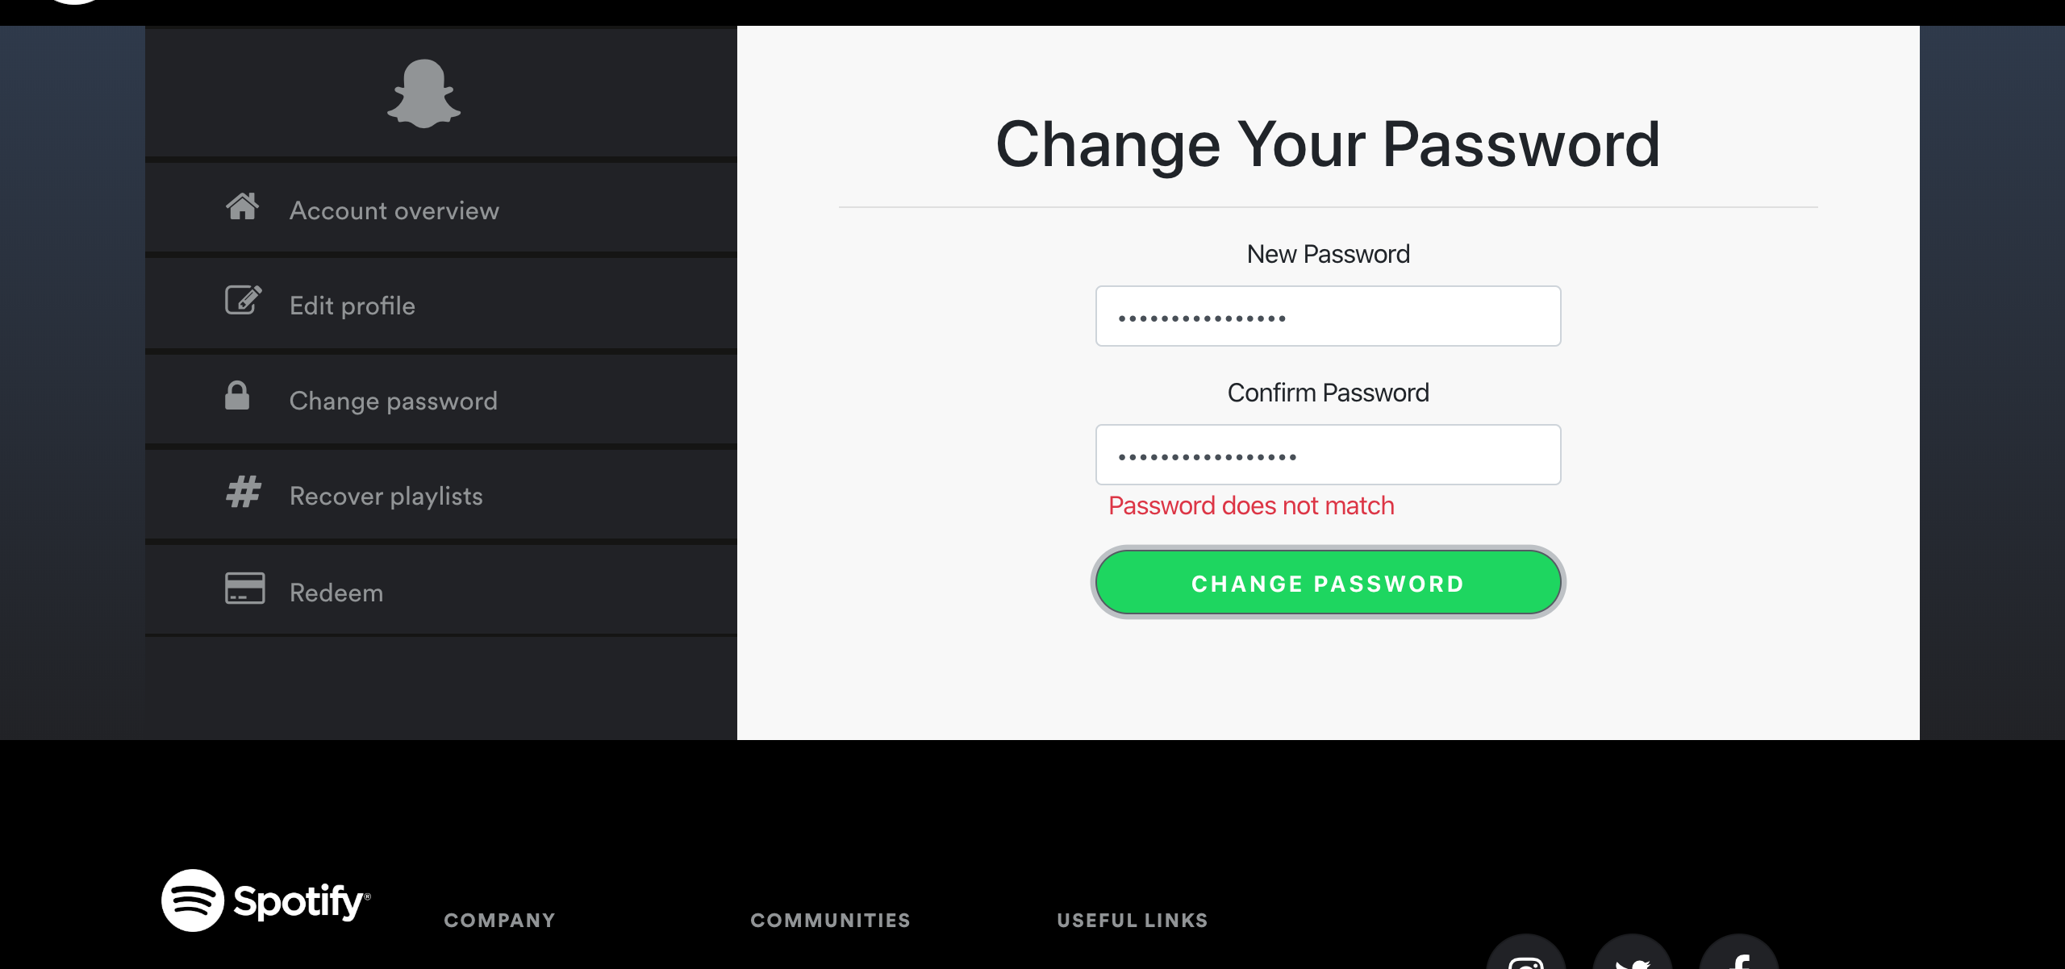

[Attachment] stdout

## Test Teardown

[Fixture] setup_final::0

# Clicking Liked Songs Card text - failed

Clicking on the Liked Songs Text in the card in Your Library Page

## Details

AssertionError: assert False

|  |
| --- |
| self = <Web_Testing.Tests.test_yourLibrary.TestWebPlayerLibrary object at 0x11092d040> setup = None   @allure.severity(allure.severity_level.BLOCKER)  @allure.story("Clicking on the Liked Songs Text in the card in Your Library Page")  @allure.title("Clicking Liked Songs Card text")  @allure.description("Clicking on the Liked Songs Text in the card in Your Library Page")  @pytest.mark.Do  @pytest.mark.YourLibrary  def test_case_3(self, setup):  time.sleep(2)  web_player_home = WebPlayerHome(self.driver)  web_player_home.click_your_library()  time.sleep(2)  web_player_library = WebPlayerLibrary(self.driver)  web_player_library.click_liked_songs_txt()  if self.helper.url_has("webplayer/likedplay"):  self.helper.report_allure("SUCCESS: The Liked Songs Card button in your Library page is functional")  assert True  else:  self.helper.report_allure("FAILURE: The Liked Songs Card button in your Library page is not functional") > assert False E assert False  Web_Testing/Tests/test_yourLibrary.py:117: AssertionError |

## Test Setup

[Fixture] setup

## Test Body

[Attachment] FAILURE: The Liked Songs Card button in your Library page is not functional

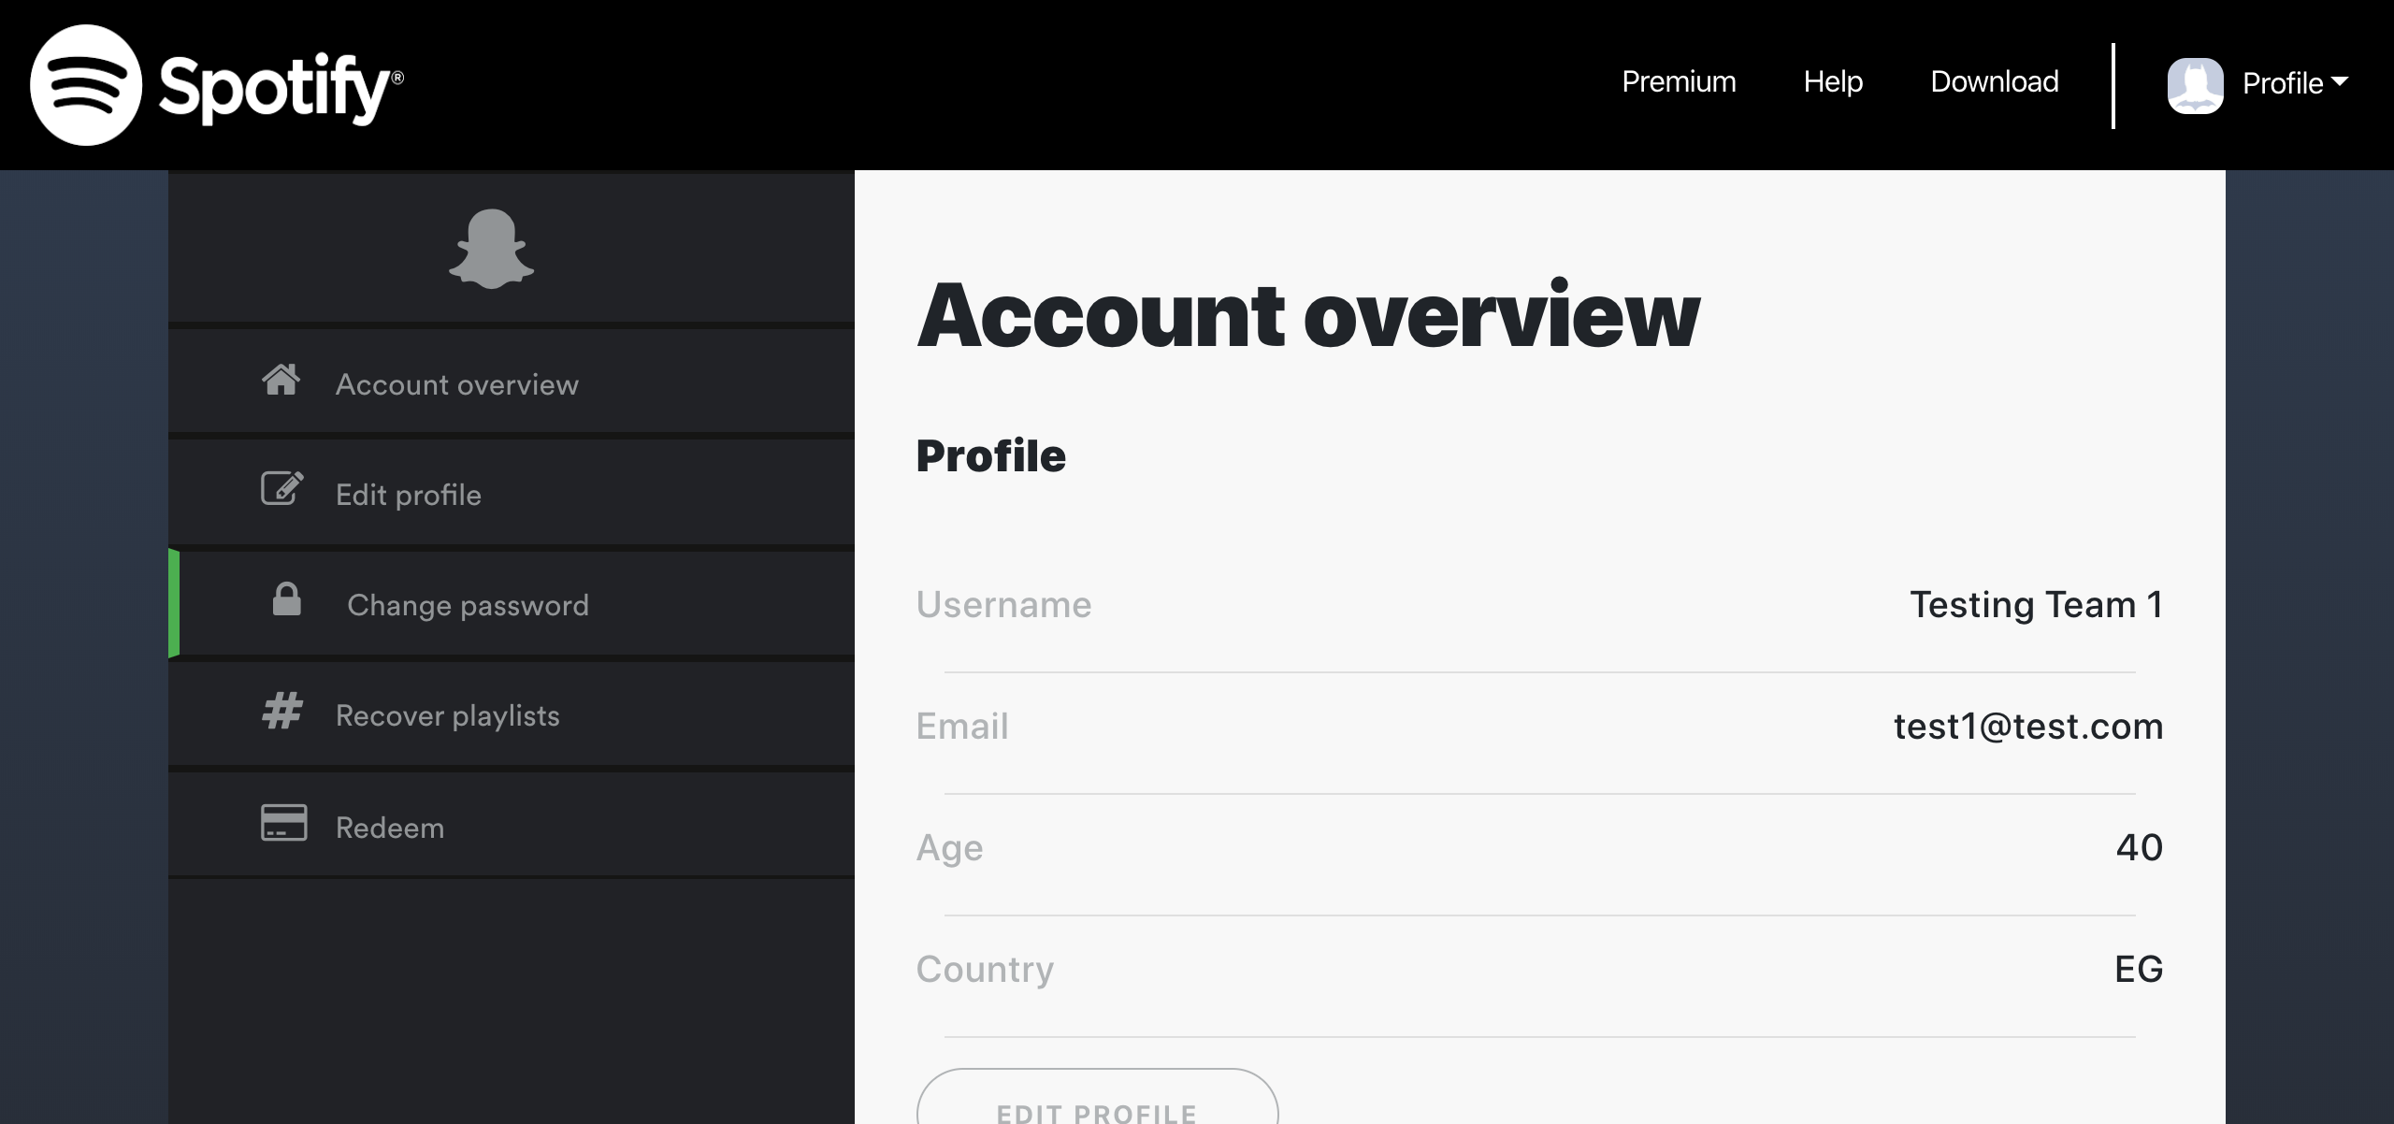

## Test Teardown

[Fixture] setup::0

# Refresh Page test - failed

Testing to refresh page that elements are still available

## Details

AssertionError: assert False

|  |
| --- |
| self = <Web_Testing.Tests.test_signup.TestSignup object at 0x10db54df0> setup = None   @allure.severity(allure.severity_level.BLOCKER)  @allure.story("Refresh Page test")  @allure.sub_suite("Refresh Page test")  @allure.title("Refresh Page test")  @allure.description("Testing to refresh page that elements are still available")  @pytest.mark.Do  @pytest.mark.Signup  def test_case_11(self, setup):  time.sleep(2)  self.driver.refresh()  sp = SignupPage(self.driver)    if (sp.email_txt is None) or (sp.password_txt is None) or (sp.confirm_email_txt is None) \  or (sp.display_name_txt is None) or (sp.dob_day_txt is None) or (sp.dob_month_txt is None) \  or (sp.dob_year_txt is None) or (sp.gender_male is None) or (sp.gender_female is None) \  or (sp.signup is None) or (sp.is_text_dangers_visible()):  WebHelper().report_allure(  "ERROR: Some elements are not available after refresh OR Invalid text warnings appeared after refresh"  , self.driver) > assert False E assert False  Web_Testing/Tests/test_signup.py:296: AssertionError |

## Test Setup

[Fixture] setup

## Test Body

[Attachment] ERROR: Some elements are not available after refresh OR Invalid text warnings appeared after refresh

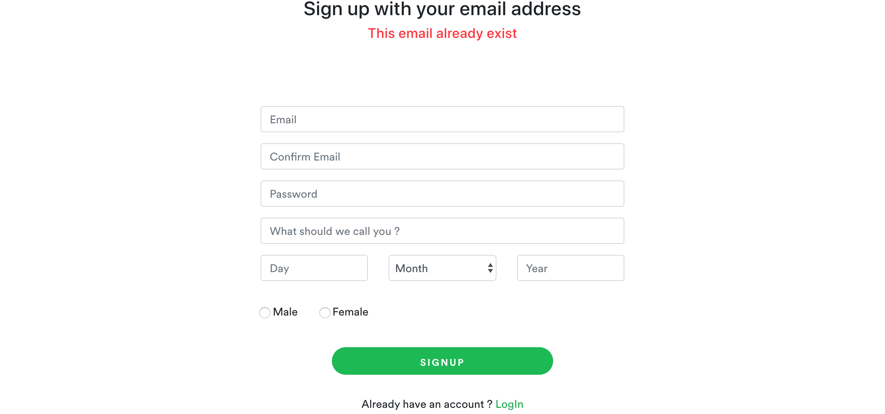

## Test Teardown

[Fixture] setup::0

# Sign up with correct credentials and values - failed

Signing up with the following credentials and values -> Email: test54@test.com, Pass: test545556

## Details

AssertionError: assert False

|  |
| --- |
| self = <Web_Testing.Tests.test_signup.TestSignup object at 0x10dc03910> setup = None   @allure.severity(allure.severity_level.BLOCKER)  @allure.story("Succes Signup")  @allure.sub_suite("Sign up with correct credentials and values")  @allure.title("Sign up with correct credentials and values")  @allure.description(  "Signing up with the following credentials and values -> Email: test54@test.com, Pass: test545556")  @pytest.mark.Do  @pytest.mark.Signup  def test_case_4(self, setup):  time.sleep(3)  sp = SignupPage(self.driver)  sp.check_signup_page()  constants = ConstantsClass()  profile = constants.get_profile(self.correct_emails[0])  if sp.signup_to_spotify(profile):  WebHelper().report_allure("SUCCESS: Sign up with correct credentials and values proceeded", self.driver)  assert True  else:  WebHelper().report_allure("ERROR: Sign up did not proceed with correct credentials and values", self.driver) > assert False E assert False  Web_Testing/Tests/test_signup.py:142: AssertionError |

## Test Setup

[Fixture] setup

## Test Body

[Attachment] ERROR: Sign up did not proceed with correct credentials and values

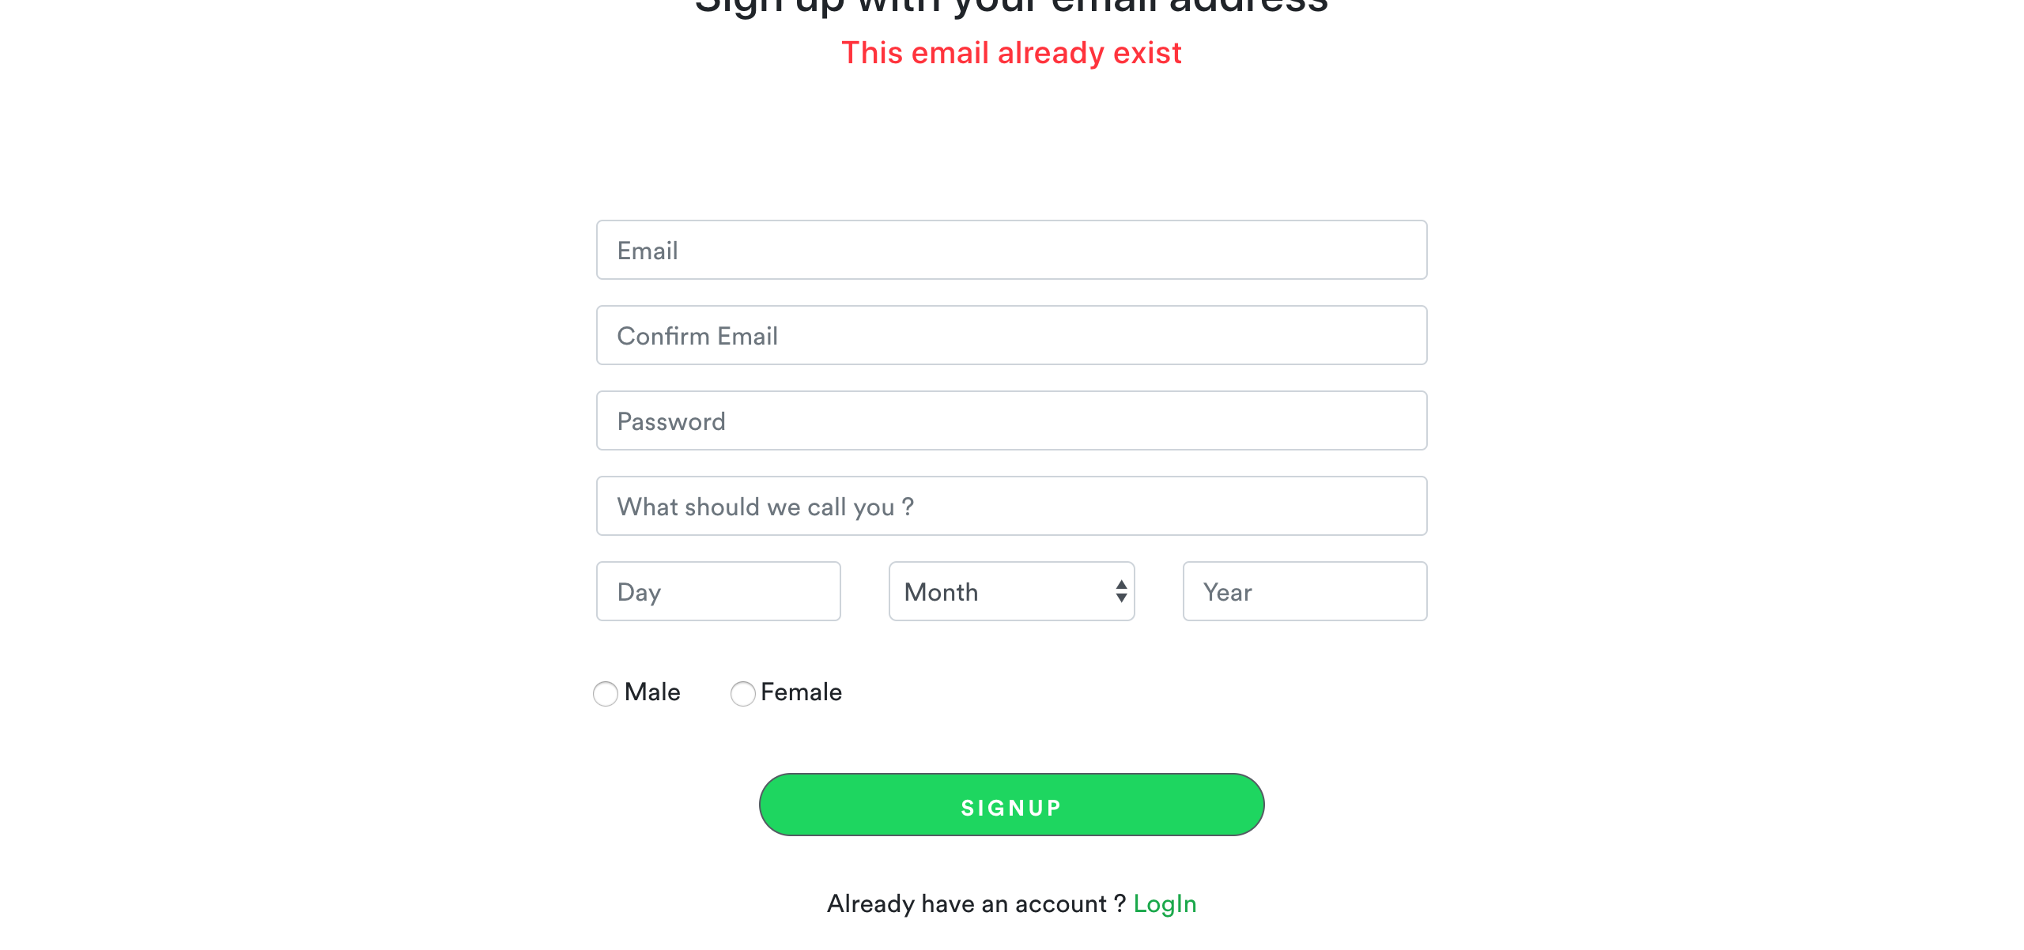

[Attachment] stdout

## Test Teardown

[Fixture] setup::0

# Sign up with different confirmation email - failed

Signing up with different confirmation email from the original email field

## Details

AssertionError: assert False

|  |
| --- |
| self = <Web_Testing.Tests.test_signup.TestSignup object at 0x10da68250> setup = None   @allure.severity(allure.severity_level.BLOCKER)  @allure.story("Failing Signup")  @allure.sub_suite("Sign up with different confirmation email")  @allure.title("Sign up with different confirmation email")  @allure.description("Signing up with different confirmation email from the original email field")  @pytest.mark.Do  @pytest.mark.Signup  def test_case_1(self, setup):  time.sleep(2)  sp = SignupPage(self.driver)  self.driver.implicitly_wait(3)  if not sp.check_signup_page():  WebHelper().report_allure(self.driver, "TIMEOUT: Sign up page not loading")  assert False    constants = ConstantsClass()  emails = constants.get_test_emails()  profile = Profile(emails[0], "test_pass", "Mohammad Osama", DOB(31, 1, 2002), Gender.MALE,  "another_email@hotmail.com")    if sp.signup_to_spotify(profile):  WebHelper().report_allure("ERROR: Sign up proceeded with different confirmation email", self.driver) > assert False E assert False  Web_Testing/Tests/test_signup.py:72: AssertionError |

## Test Setup

[Fixture] setup

## Test Body

[Attachment] ERROR: Sign up proceeded with different confirmation email

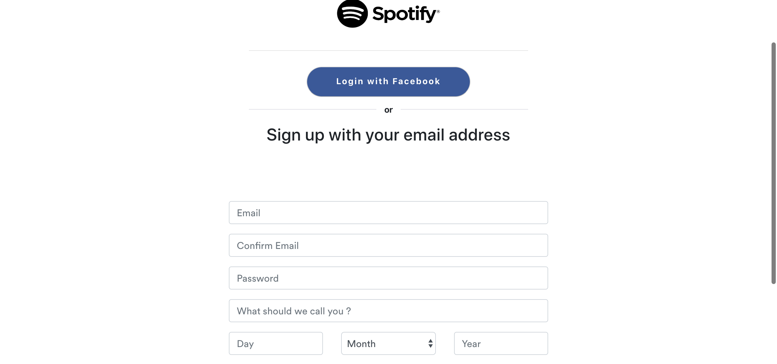

[Attachment] stdout

## Test Teardown

[Fixture] setup::0

# Testing Premium Button - failed

Testing Premium Button

## Details

AssertionError: assert False

|  |
| --- |
| self = <Web_Testing.Tests.test_loggedOutHome.TestLoggedOutHome object at 0x10cd9a0d0> setup_final = None   @allure.severity(allure.severity_level.BLOCKER)  @allure.story("Premium Button")  @allure.title("Testing Premium Button")  @allure.description("Testing Premium Button")  @pytest.mark.Do  @pytest.mark.LoggedOutHome  def test_case_3(self, setup_final):  logged_out_home = LoggedOutHome(self.driver)  logged_out_home.click_premium()  time.sleep(2)  if str(self.driver.current_url).find('premium') != -1:  WebHelper().report_allure("Premium button working", self.driver)  assert True  else:  WebHelper().report_allure("Premium button failed", self.driver) > assert False E assert False  Web_Testing/Tests/test_loggedOutHome.py:93: AssertionError |

## Test Setup

[Fixture] setup_final

## Test Body

[Attachment] Premium button failed

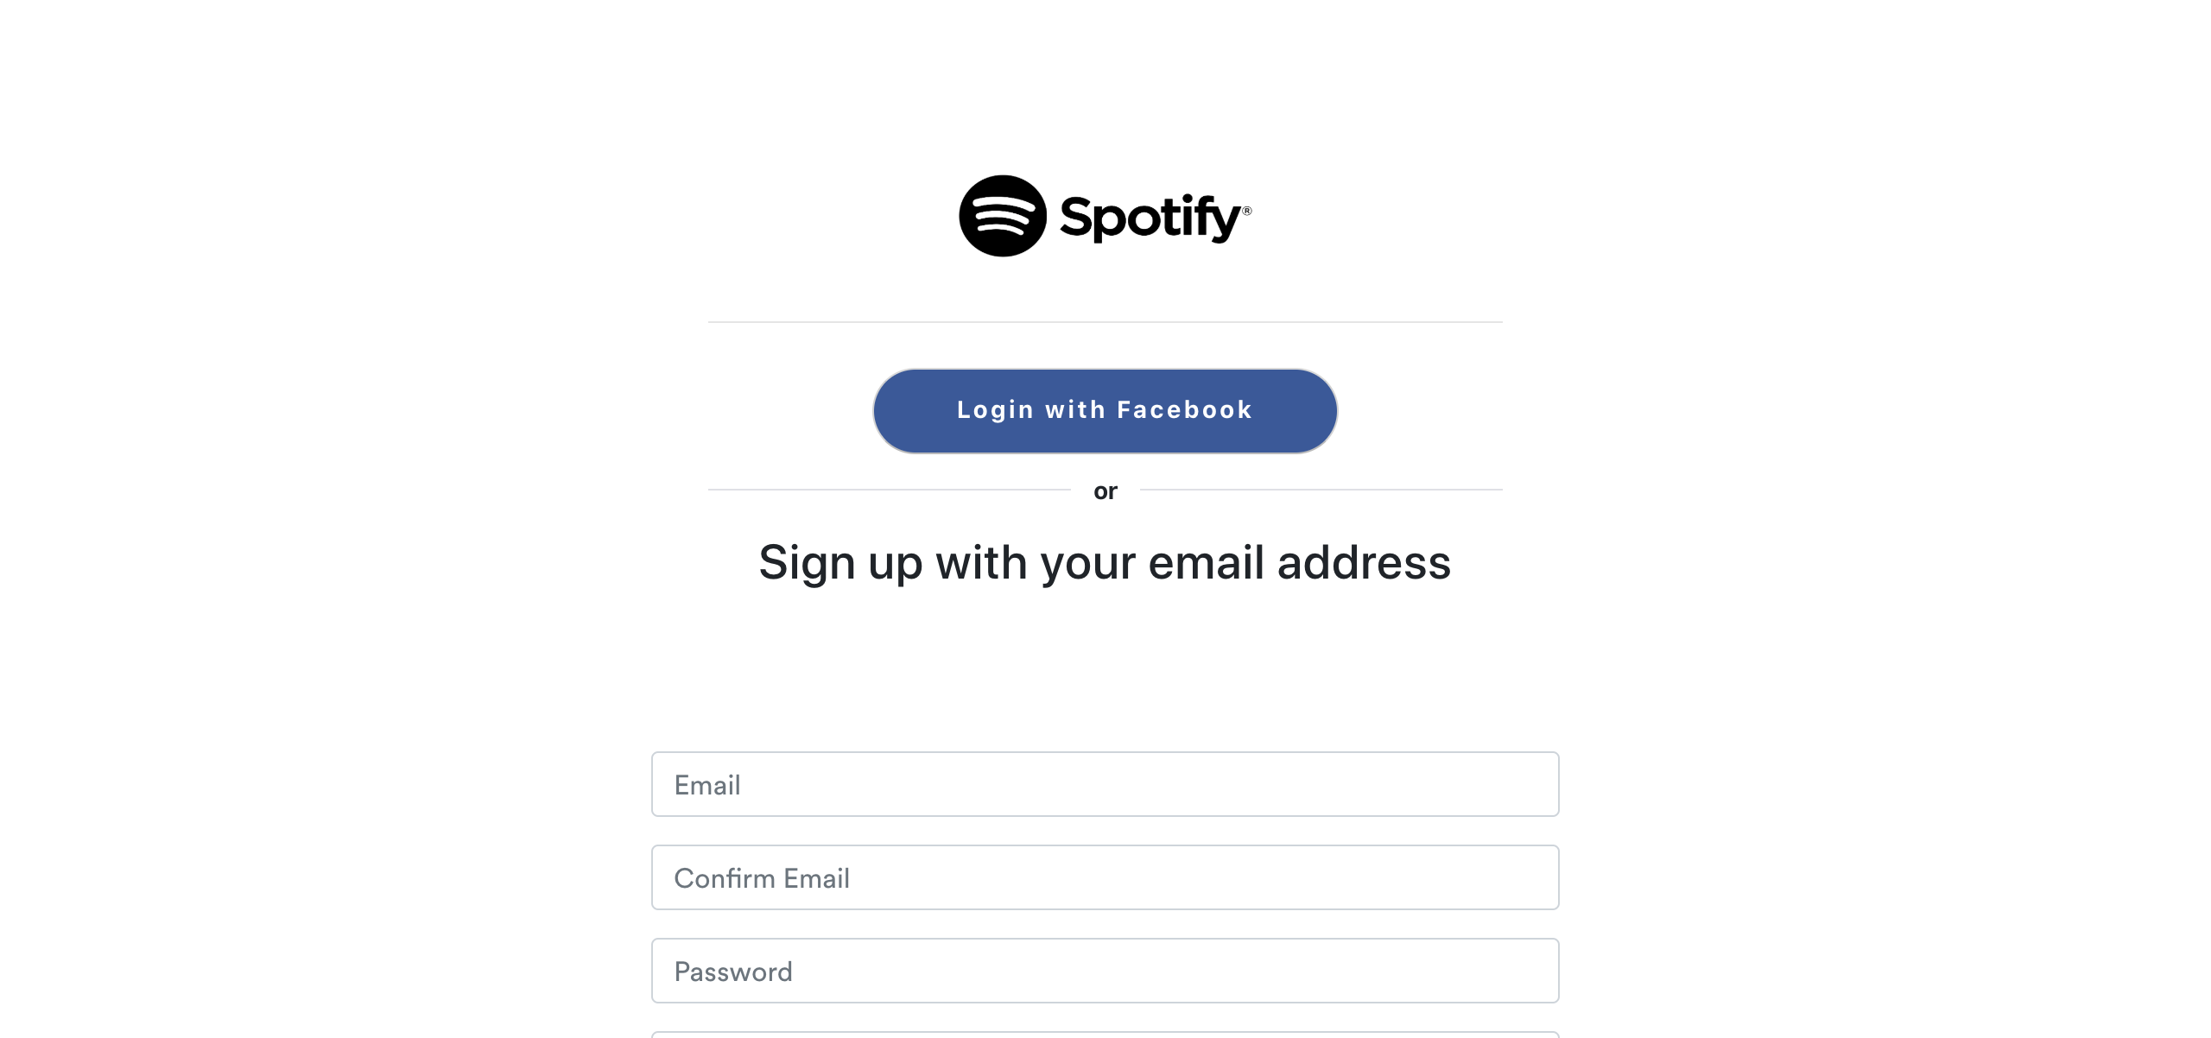

## Test Teardown

[Fixture] setup_final::0

# Albums cards - passed

Testing Albums cards

## Test Setup

[Fixture] setup

## Test Body

[Attachment] SUCCESS: Albums cards are functional

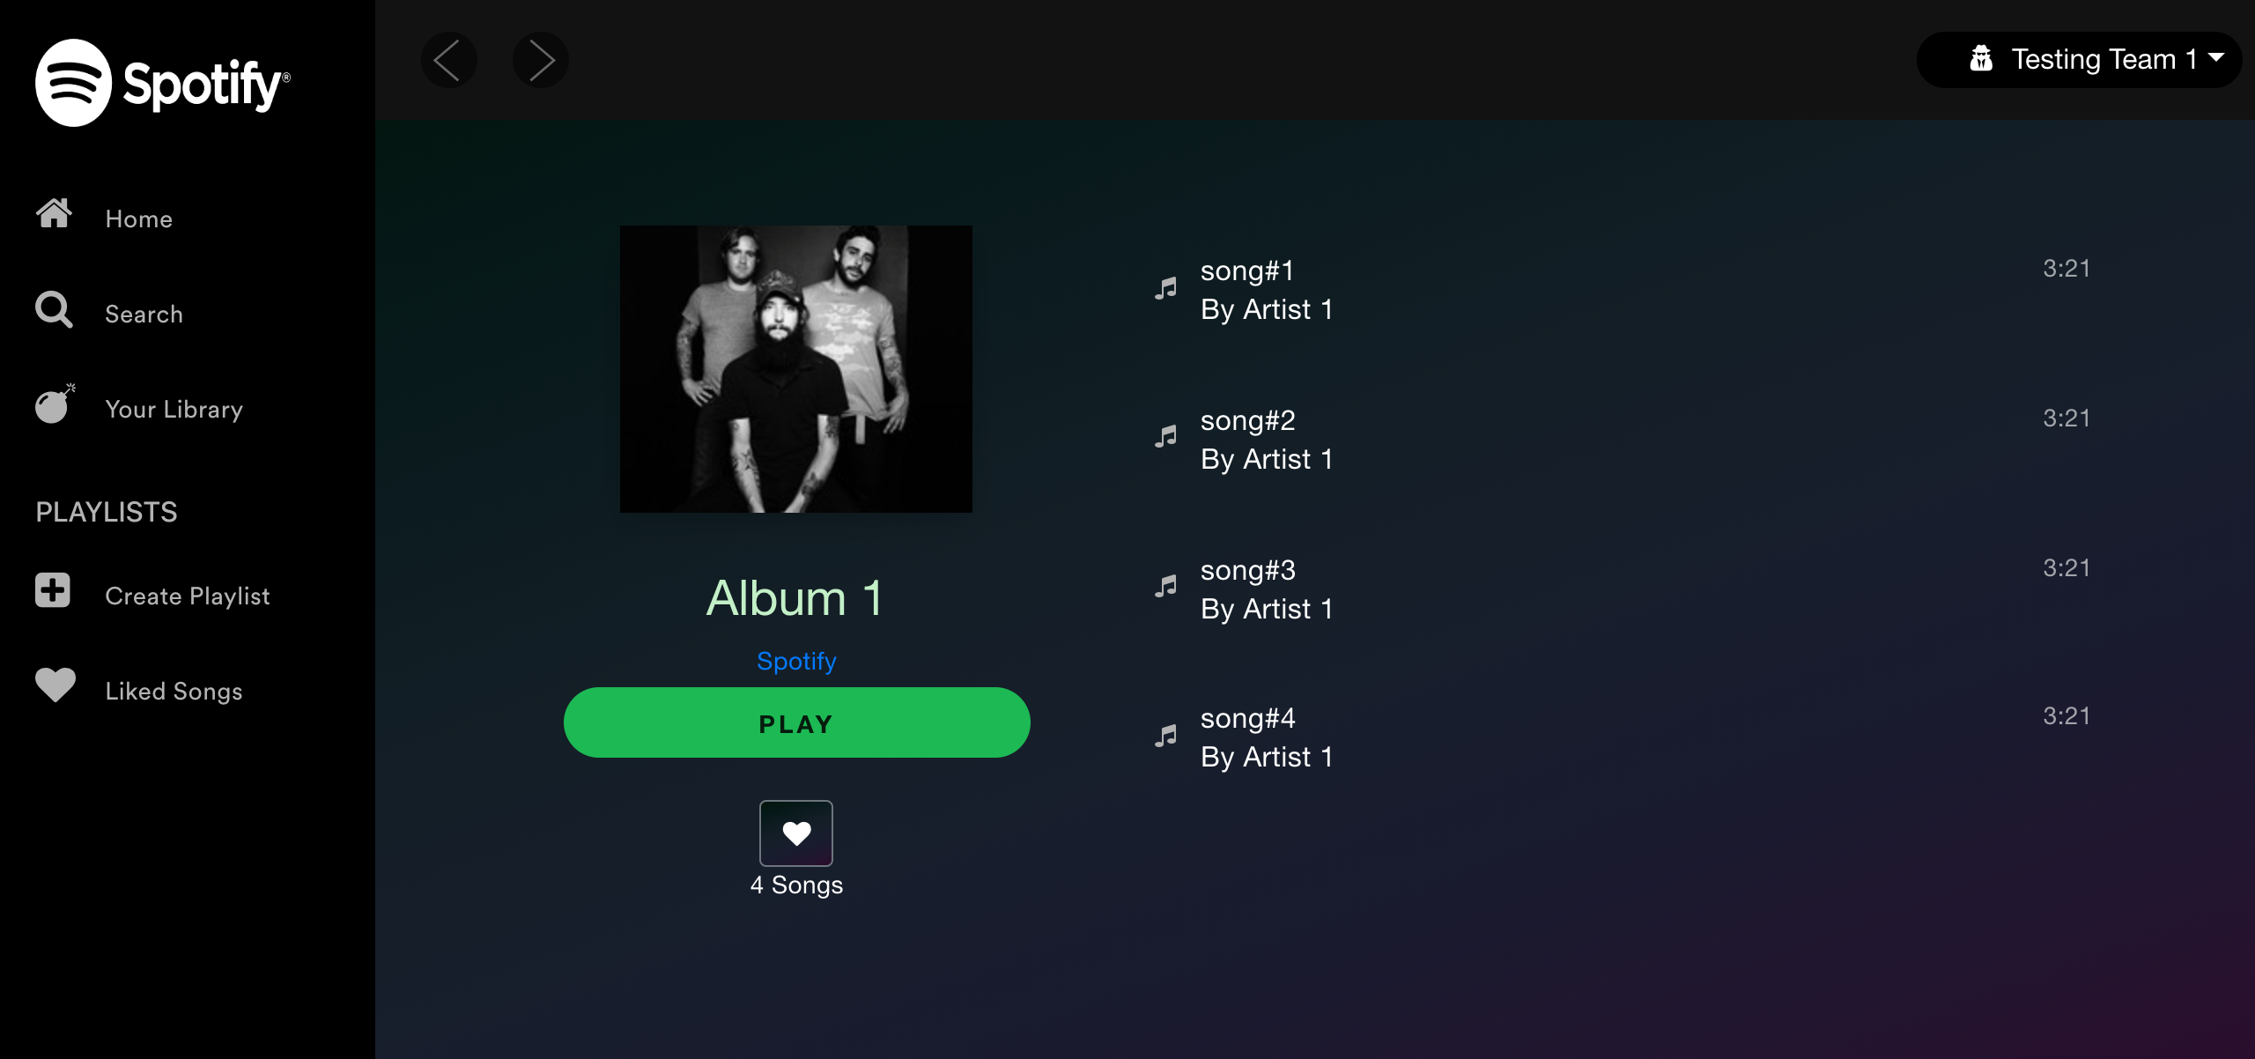

## Test Teardown

[Fixture] setup::0

# Artist cards button - passed

Testing Artists cards Button

## Test Setup

[Fixture] setup

## Test Body

[Attachment] ERROR: Playlist name is not the same as the card name. Card name = Artist 1  
Artist, Playlist name = Artist 1

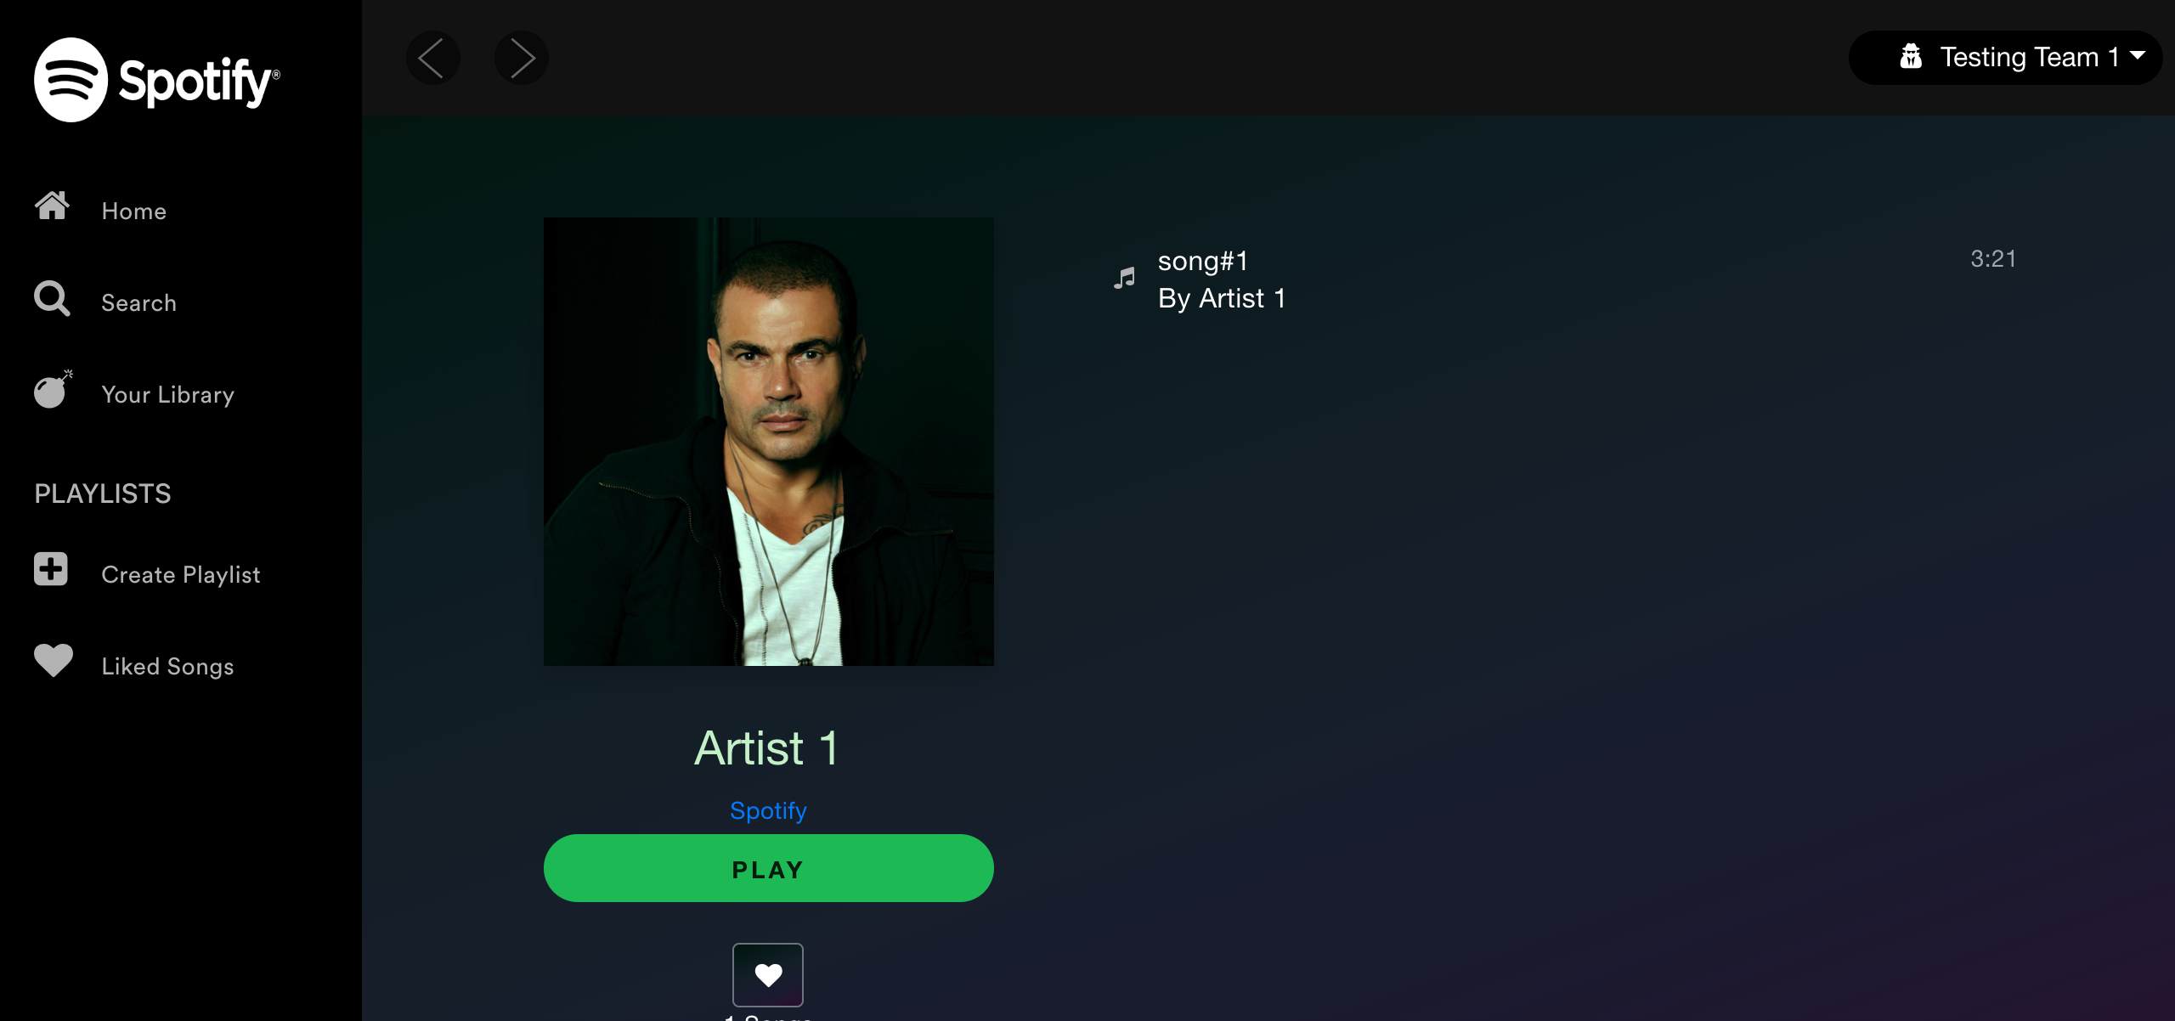

[Attachment] SUCCESS: Artists cards are functional



## Test Teardown

[Fixture] setup::0

# Change Password with different confirmation password - passed

Change Password with different confirmation password

## Test Setup

[Fixture] setup

## Test Body

[Attachment] SUCCESS: Text warnings appeared with different confirmation password

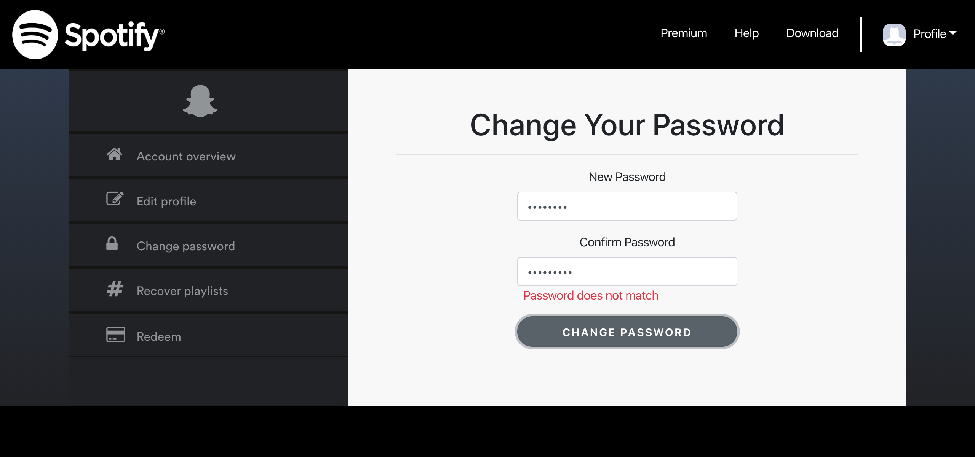

[Attachment] stdout

## Test Teardown

[Fixture] setup::0

# Change Password with empty confirmation password - passed

Change Password with empty confirmation password

## Test Setup

[Fixture] setup

## Test Body

[Attachment] ERROR: Text warnings did not appear with empty confirmation password

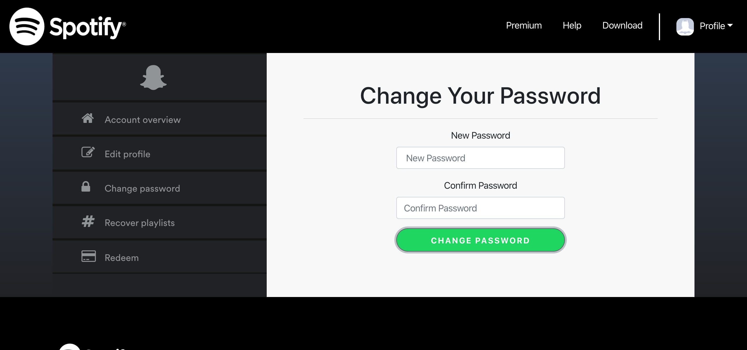

[Attachment] stdout

## Test Teardown

[Fixture] setup::0

# Change Password with empty password - passed

Testing change password with empty password

## Test Setup

[Fixture] setup_initial

## Test Body

[Attachment] SUCCESS: Text warnings appeared with empty password

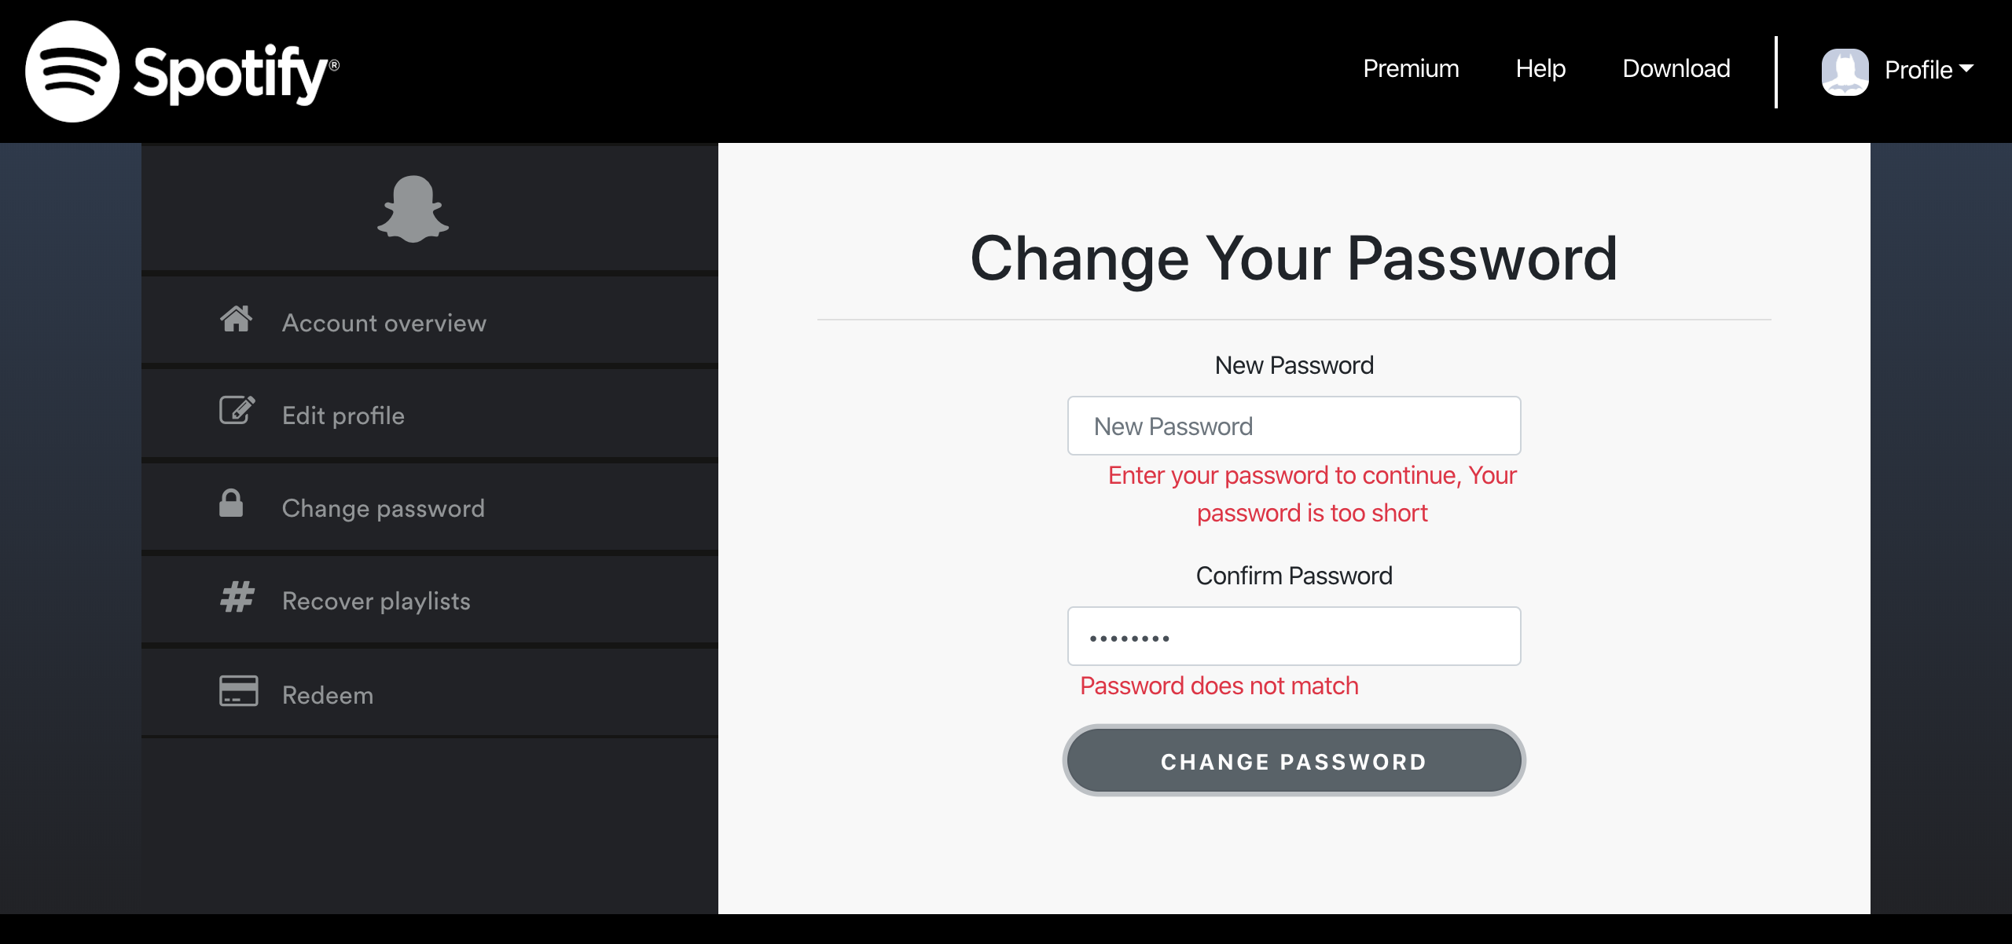

[Attachment] stdout

## Test Teardown

[Fixture] setup_initial::0

# Check right information - passed

Check user information and signing in with the following credentials email : test_projectX@hotmail.com & password:

## Test Setup

[Fixture] setup_check_information

## Test Body

[Attachment] SUCCESS: All information is correct

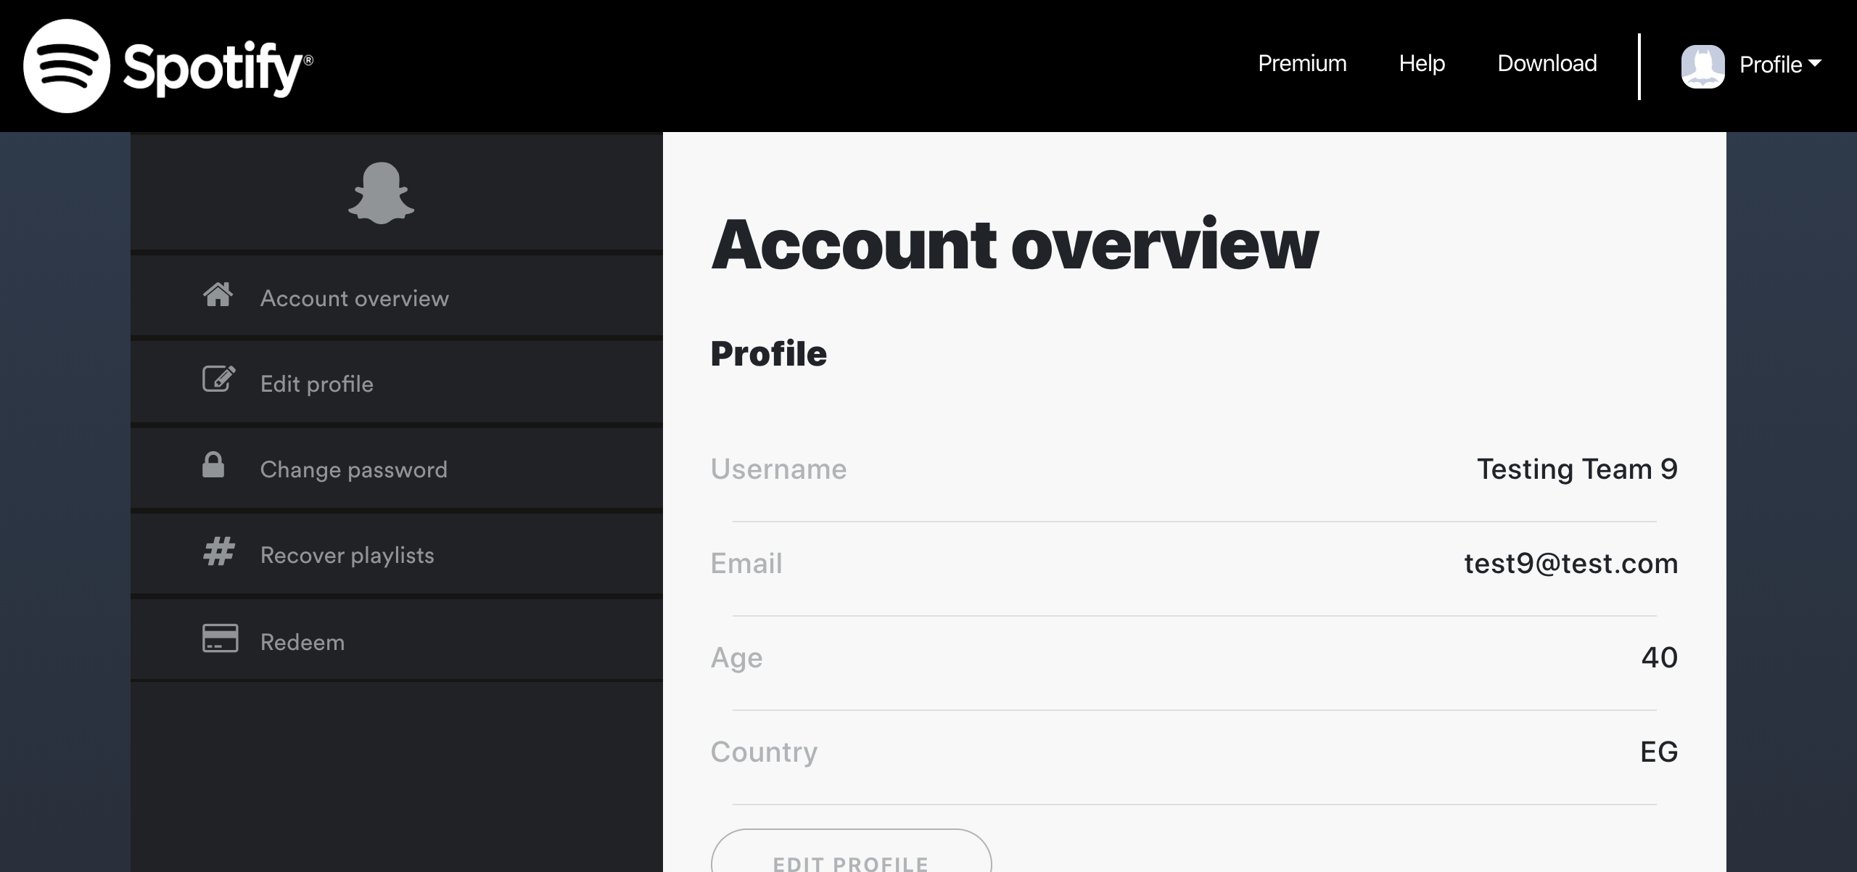

[Attachment] stdout

## Test Teardown

[Fixture] setup_check_information::0

# Clicking Download link - passed

Clicking Download link

## Test Setup

[Fixture] setup

## Test Body

[Attachment] Download link functional

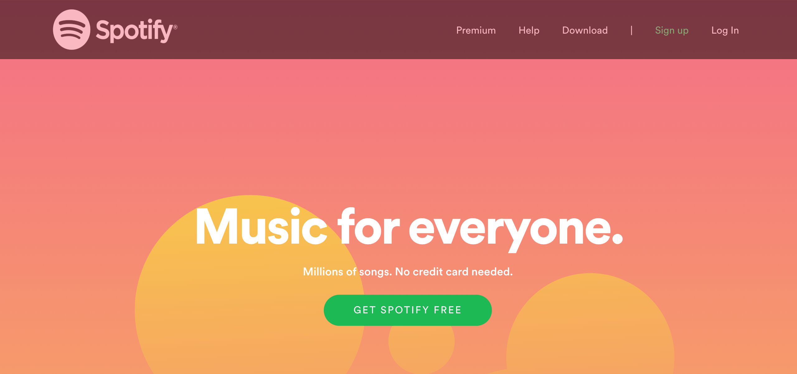

## Test Teardown

[Fixture] setup::0

# Clicking account link - passed

Clicking account link

## Test Setup

[Fixture] setup

## Test Body

[Attachment] Account link functional

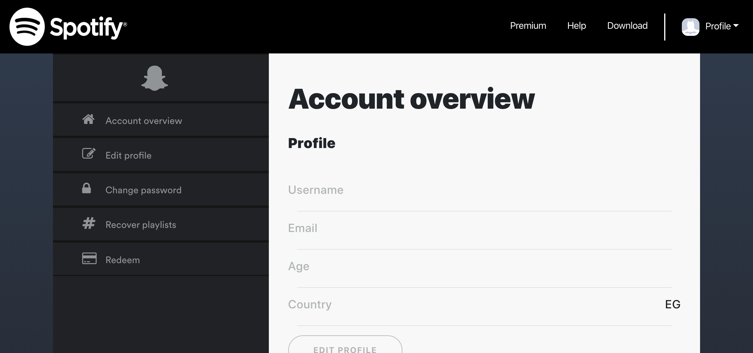

## Test Teardown

[Fixture] setup::0

# Clicking account overview link - passed

Clicking account overview link

## Test Setup

[Fixture] setup

## Test Body

[Attachment] Account Overview link functional

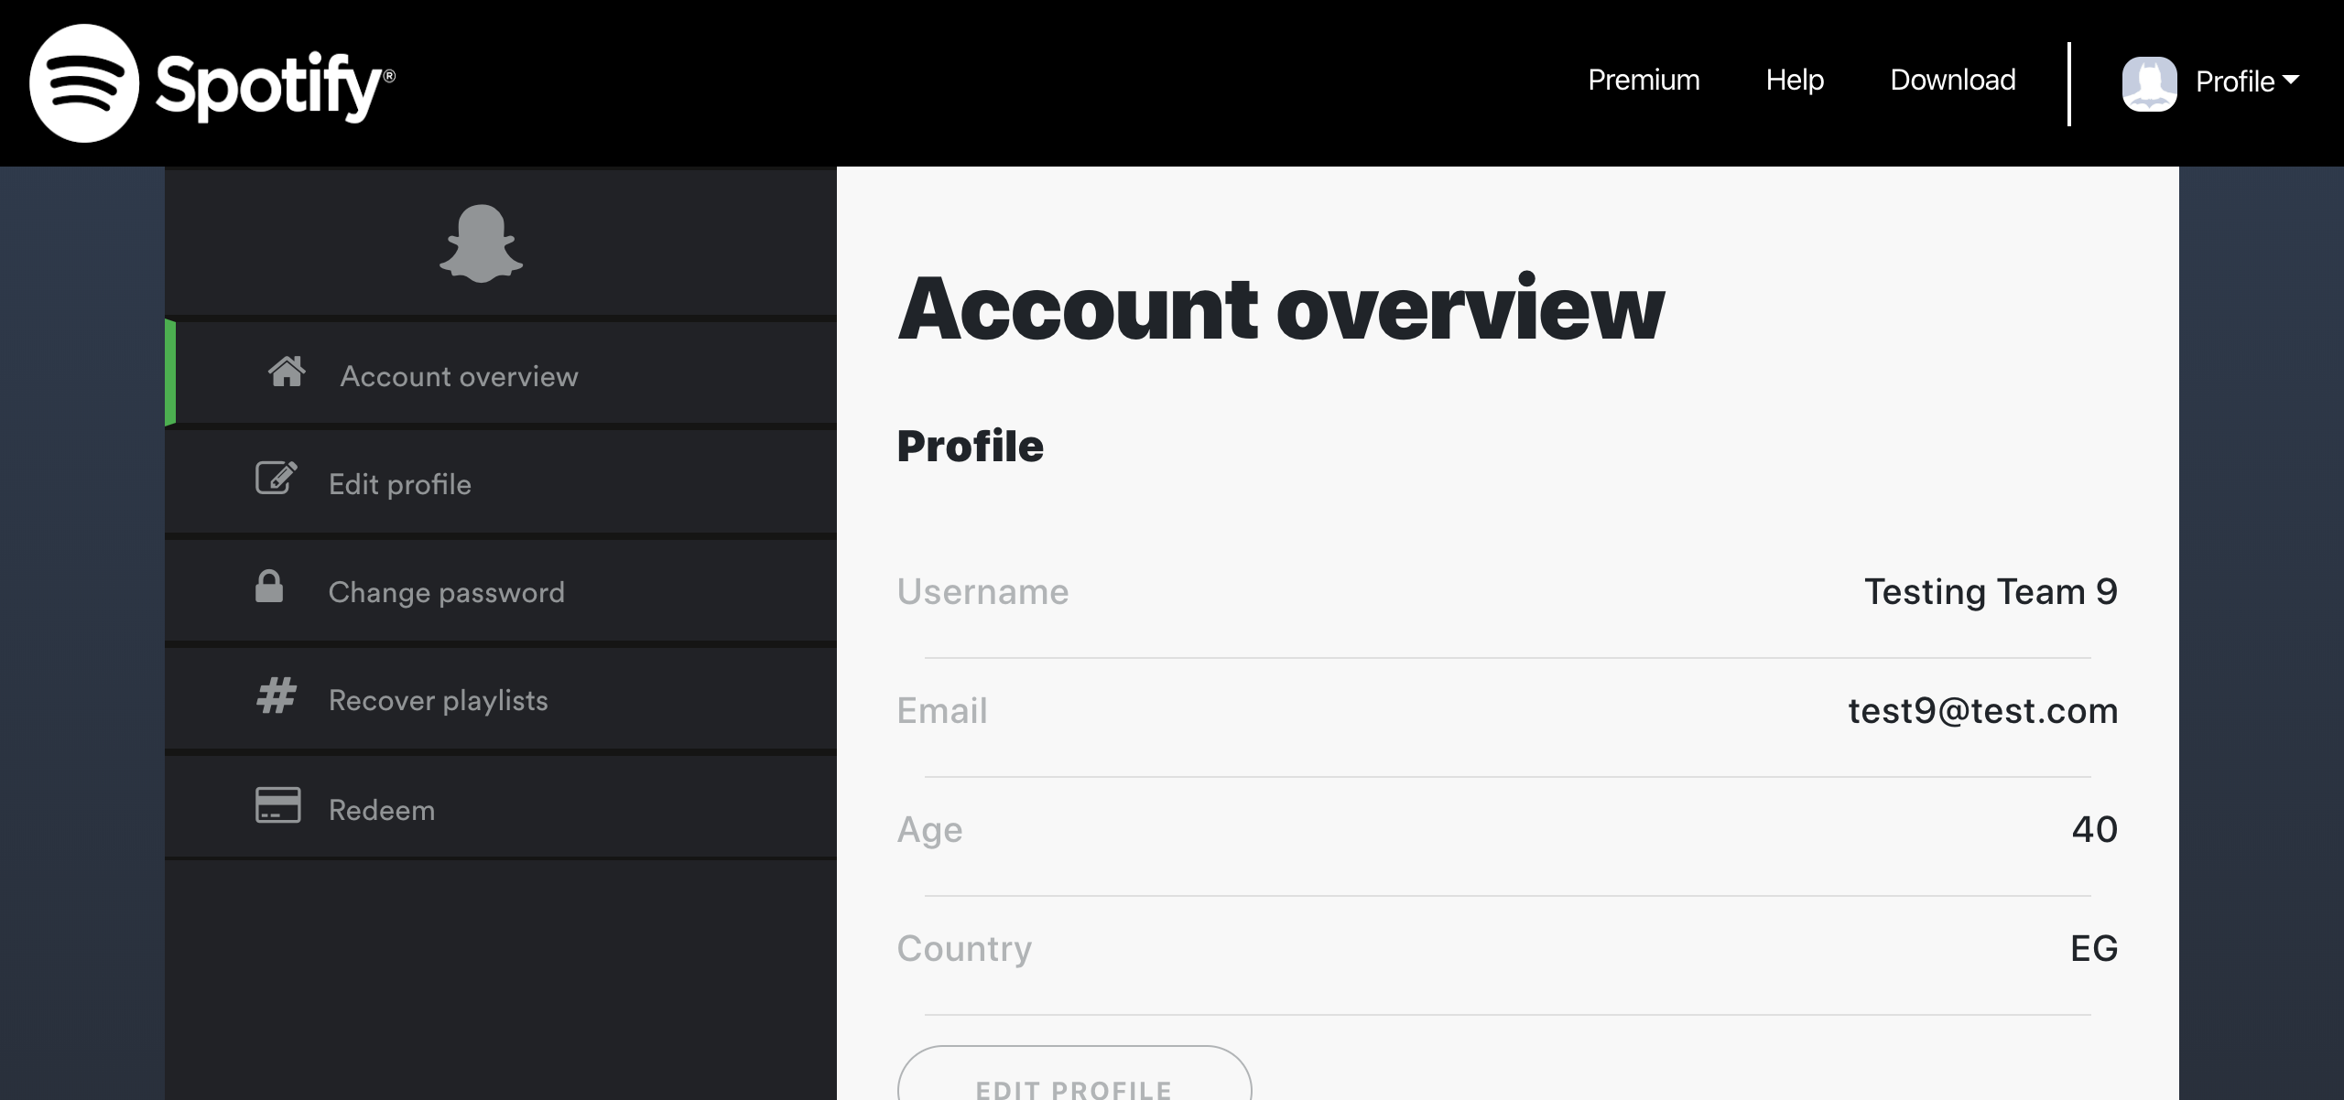

## Test Teardown

[Fixture] setup::0

# Clicking change password link - passed

Clicking change password link

## Test Setup

[Fixture] setup

## Test Body

[Attachment] Change Password link functional

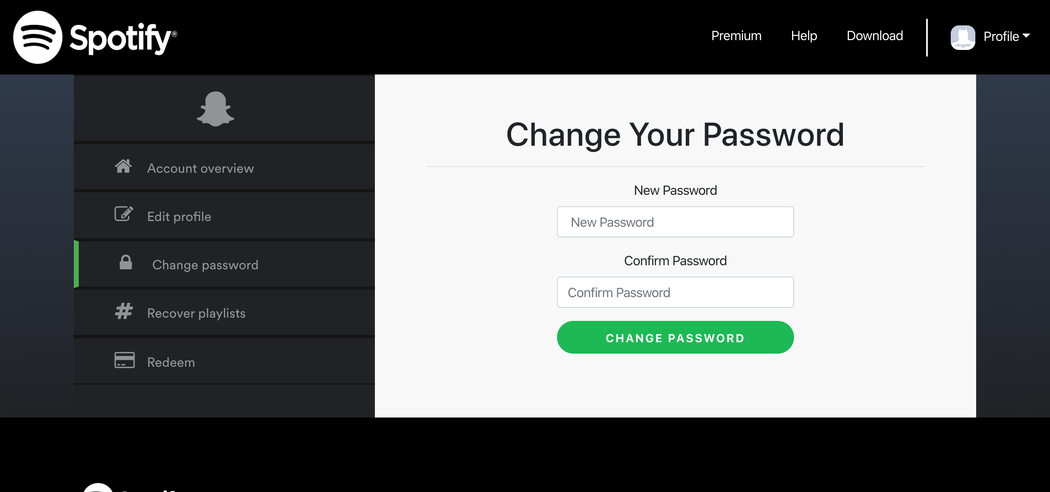

## Test Teardown

[Fixture] setup::0

# Clicking edit profile button - passed

Clicking edit profile button

## Test Setup

[Fixture] setup

## Test Body

[Attachment] edit profile button functional

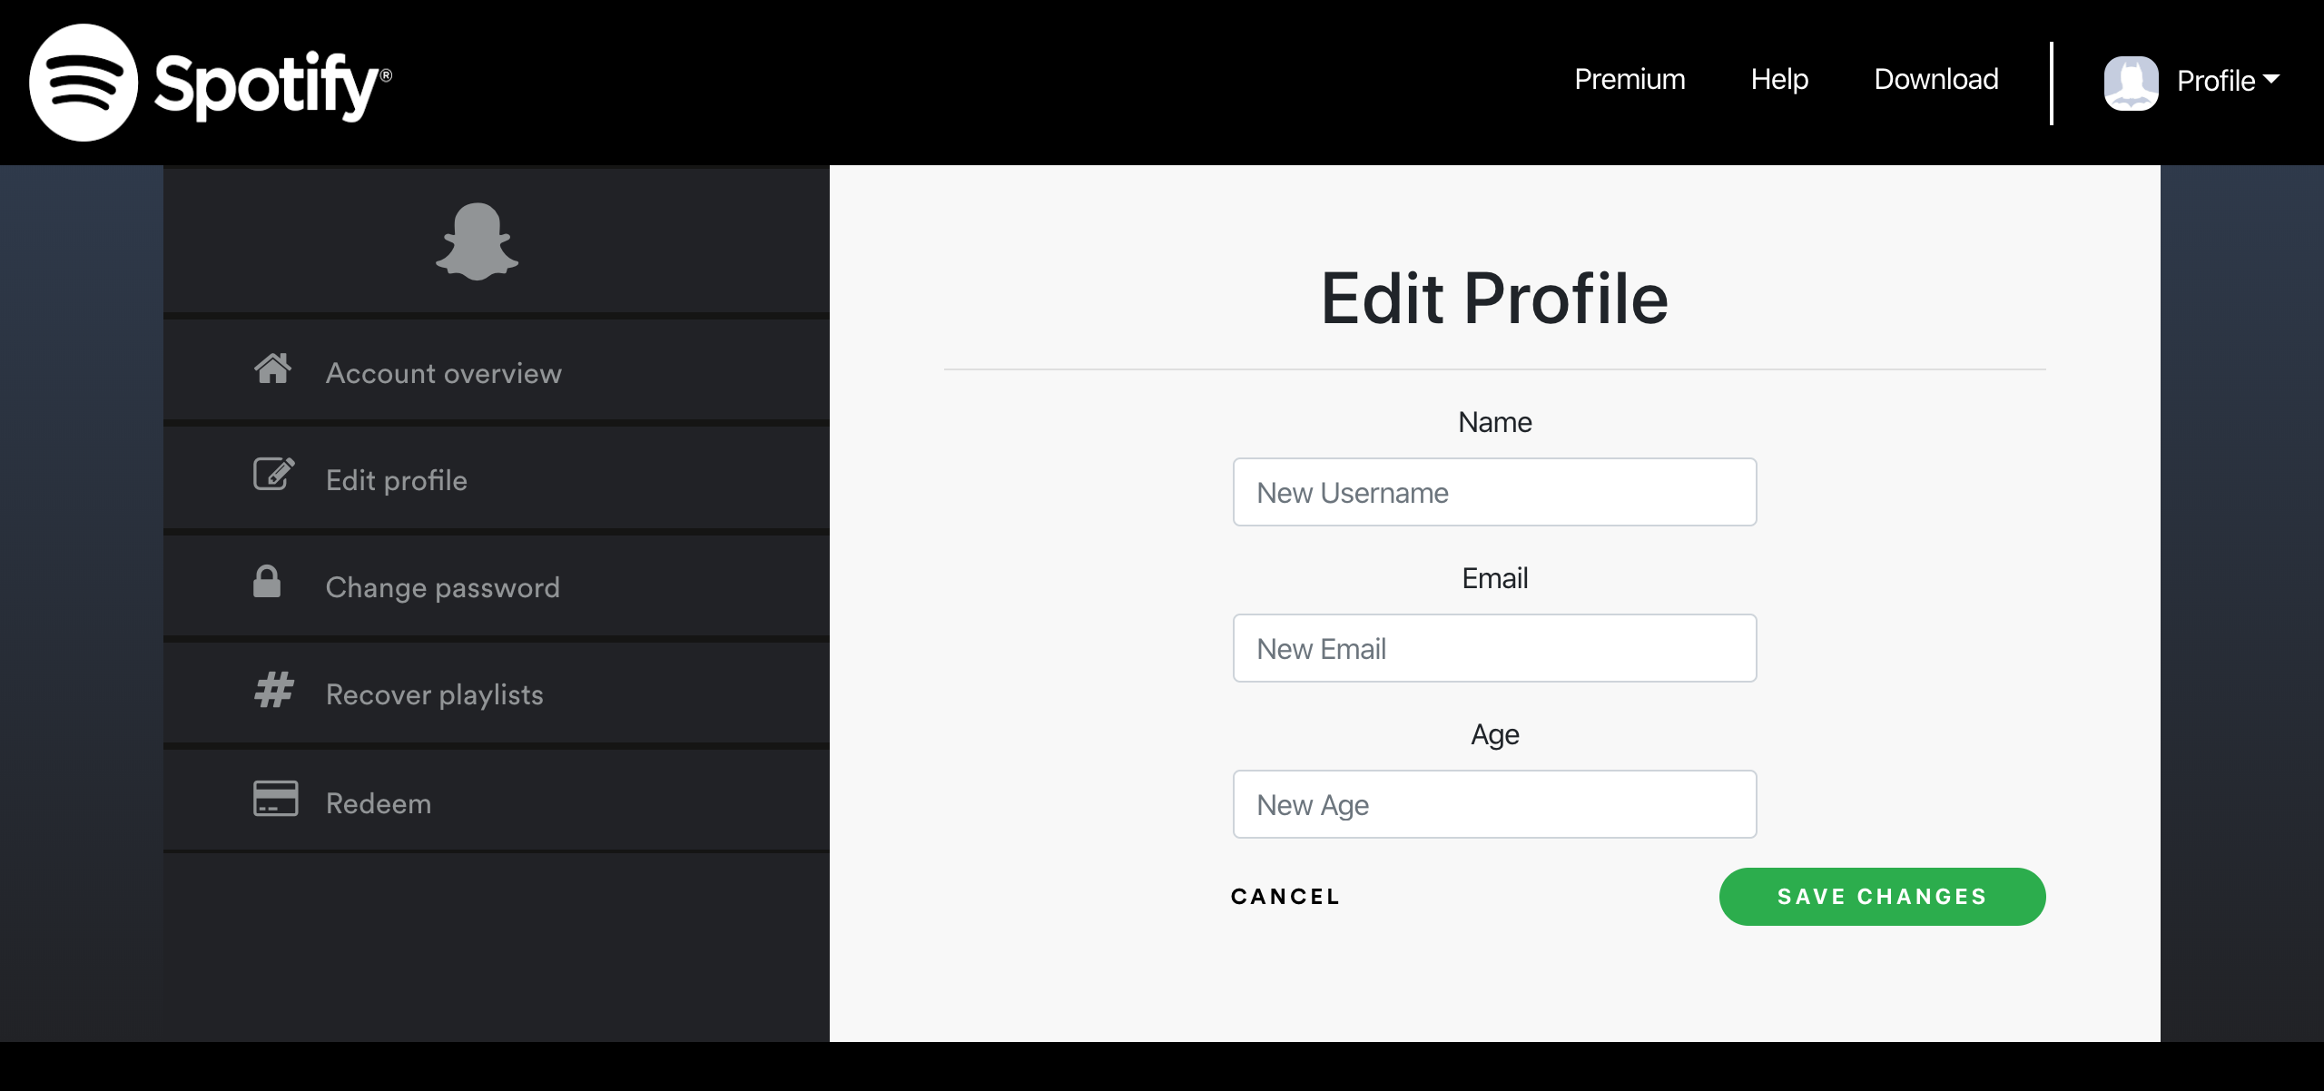

## Test Teardown

[Fixture] setup::0

# Clicking edit profile link - passed

Clicking edit profile link

## Test Setup

[Fixture] setup

## Test Body

[Attachment] Edit Profile link functional

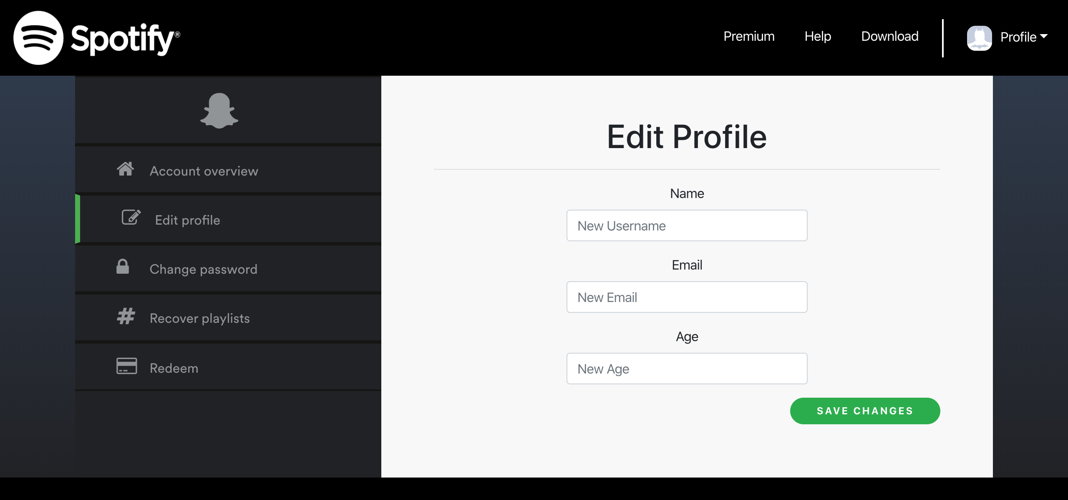

## Test Teardown

[Fixture] setup::0

# Clicking help link - passed

Clicking help link

## Test Setup

[Fixture] setup

## Test Body

[Attachment] Help link functional

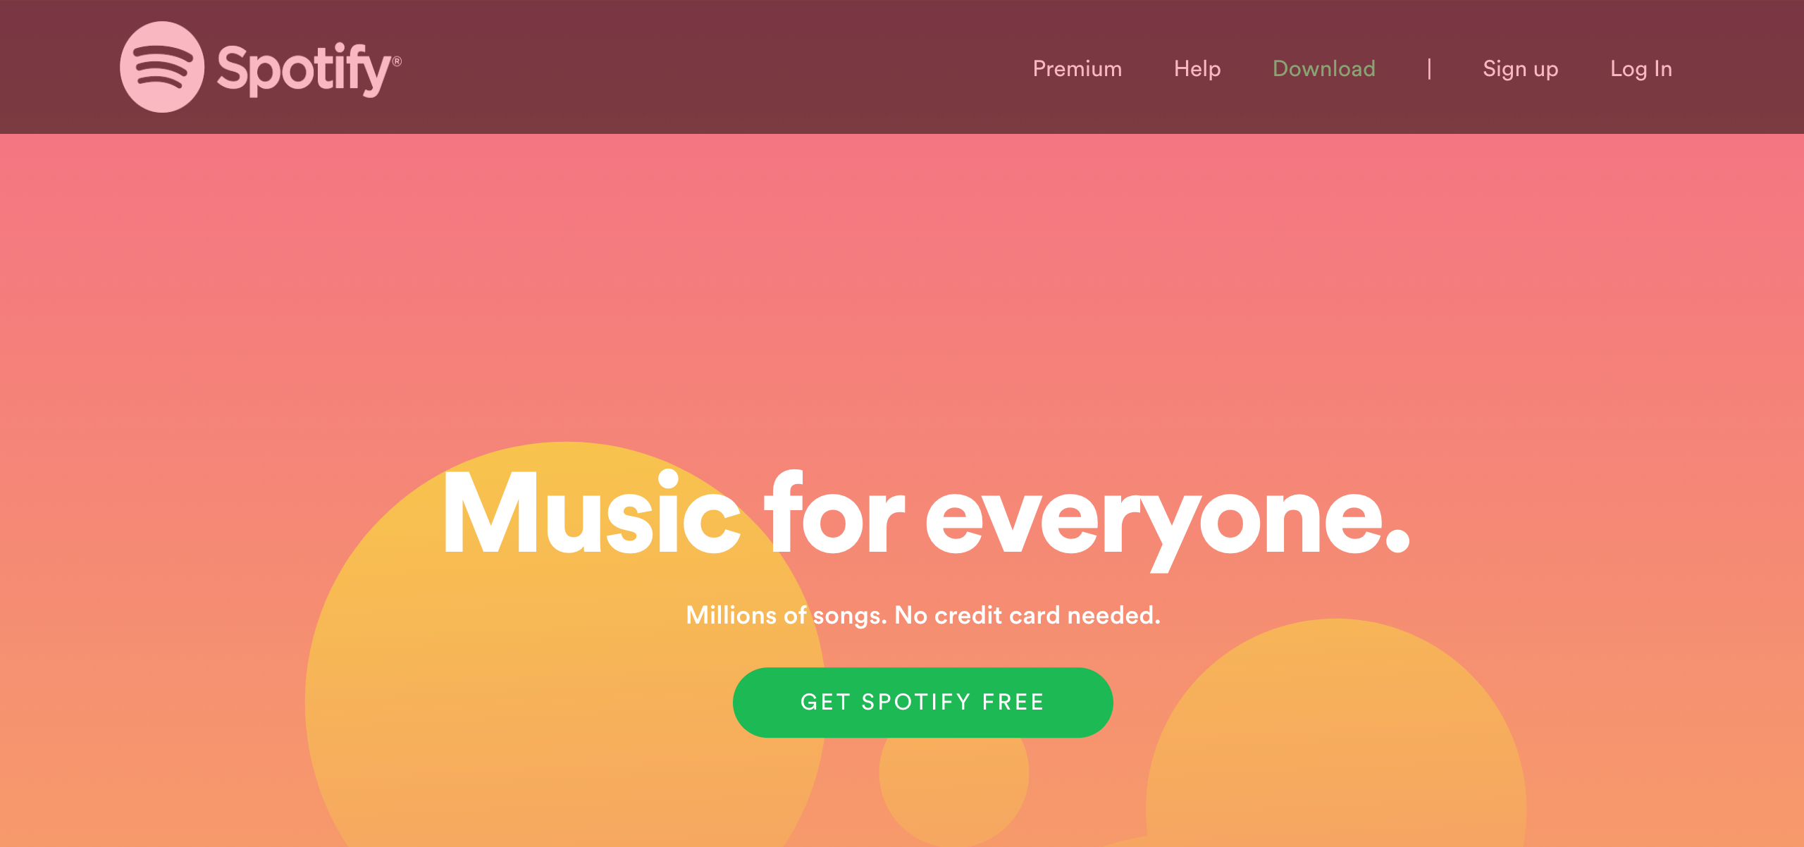

## Test Teardown

[Fixture] setup::0

# Clicking join premium button - passed

Clicking join premium button

## Test Setup

[Fixture] setup

## Test Body

[Attachment] join premium button functional

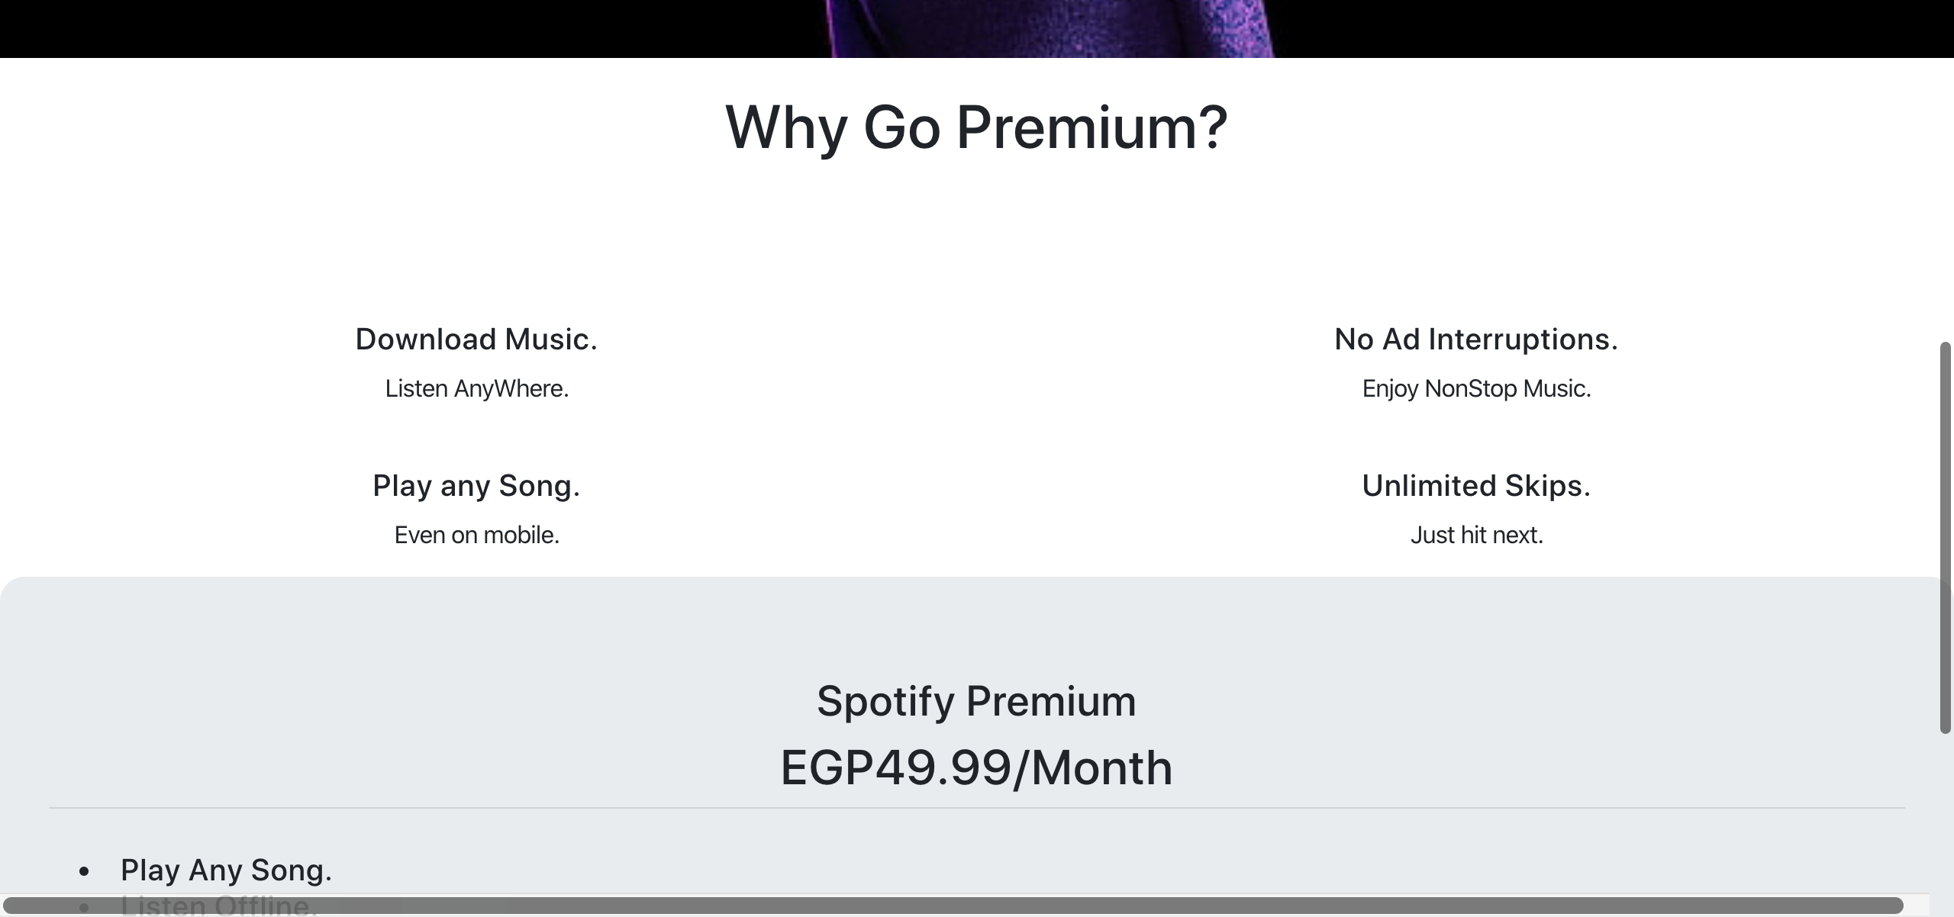

## Test Teardown

[Fixture] setup::0

# Clicking logout link - passed

Clicking logout link

## Test Setup

[Fixture] setup_final

## Test Body

[Attachment] Logout button functional



## Test Teardown

[Fixture] setup_final::0

# Clicking premium link - passed

Clicking premium link

## Test Setup

[Fixture] setup

## Test Body

[Attachment] Premium link functional

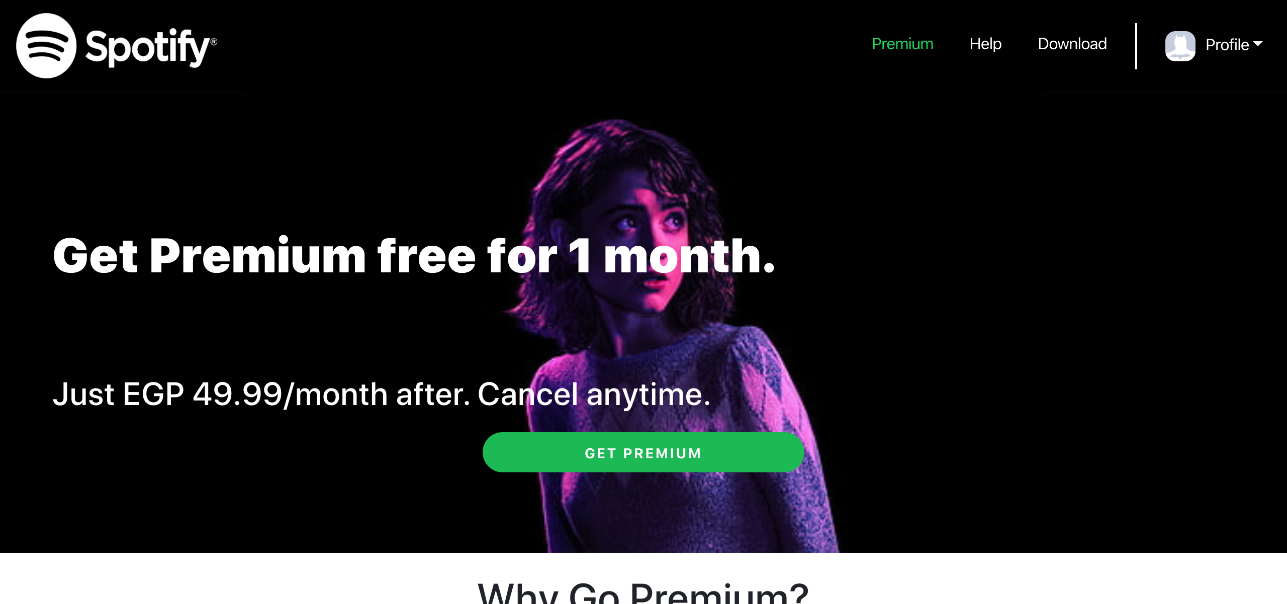

## Test Teardown

[Fixture] setup::0

# Clicking recover playlists link - passed

Clicking recover playlists link

## Test Setup

[Fixture] setup

## Test Body

[Attachment] Recover Playlists link functional

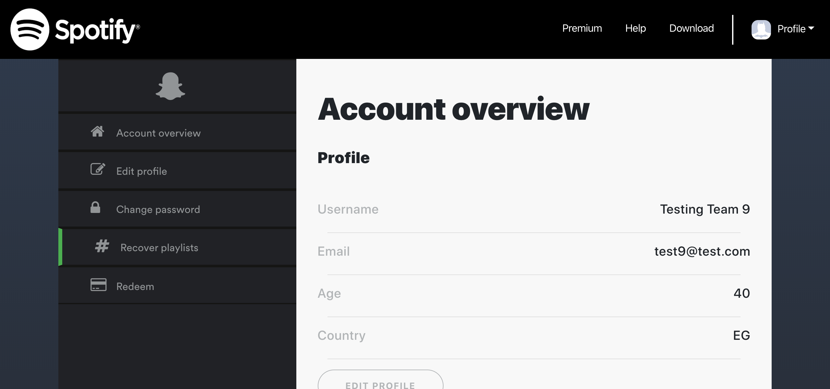

## Test Teardown

[Fixture] setup::0

# Clicking redeem link - passed

Clicking redeem link

## Test Setup

[Fixture] setup

## Test Body

[Attachment] Redeem link functional

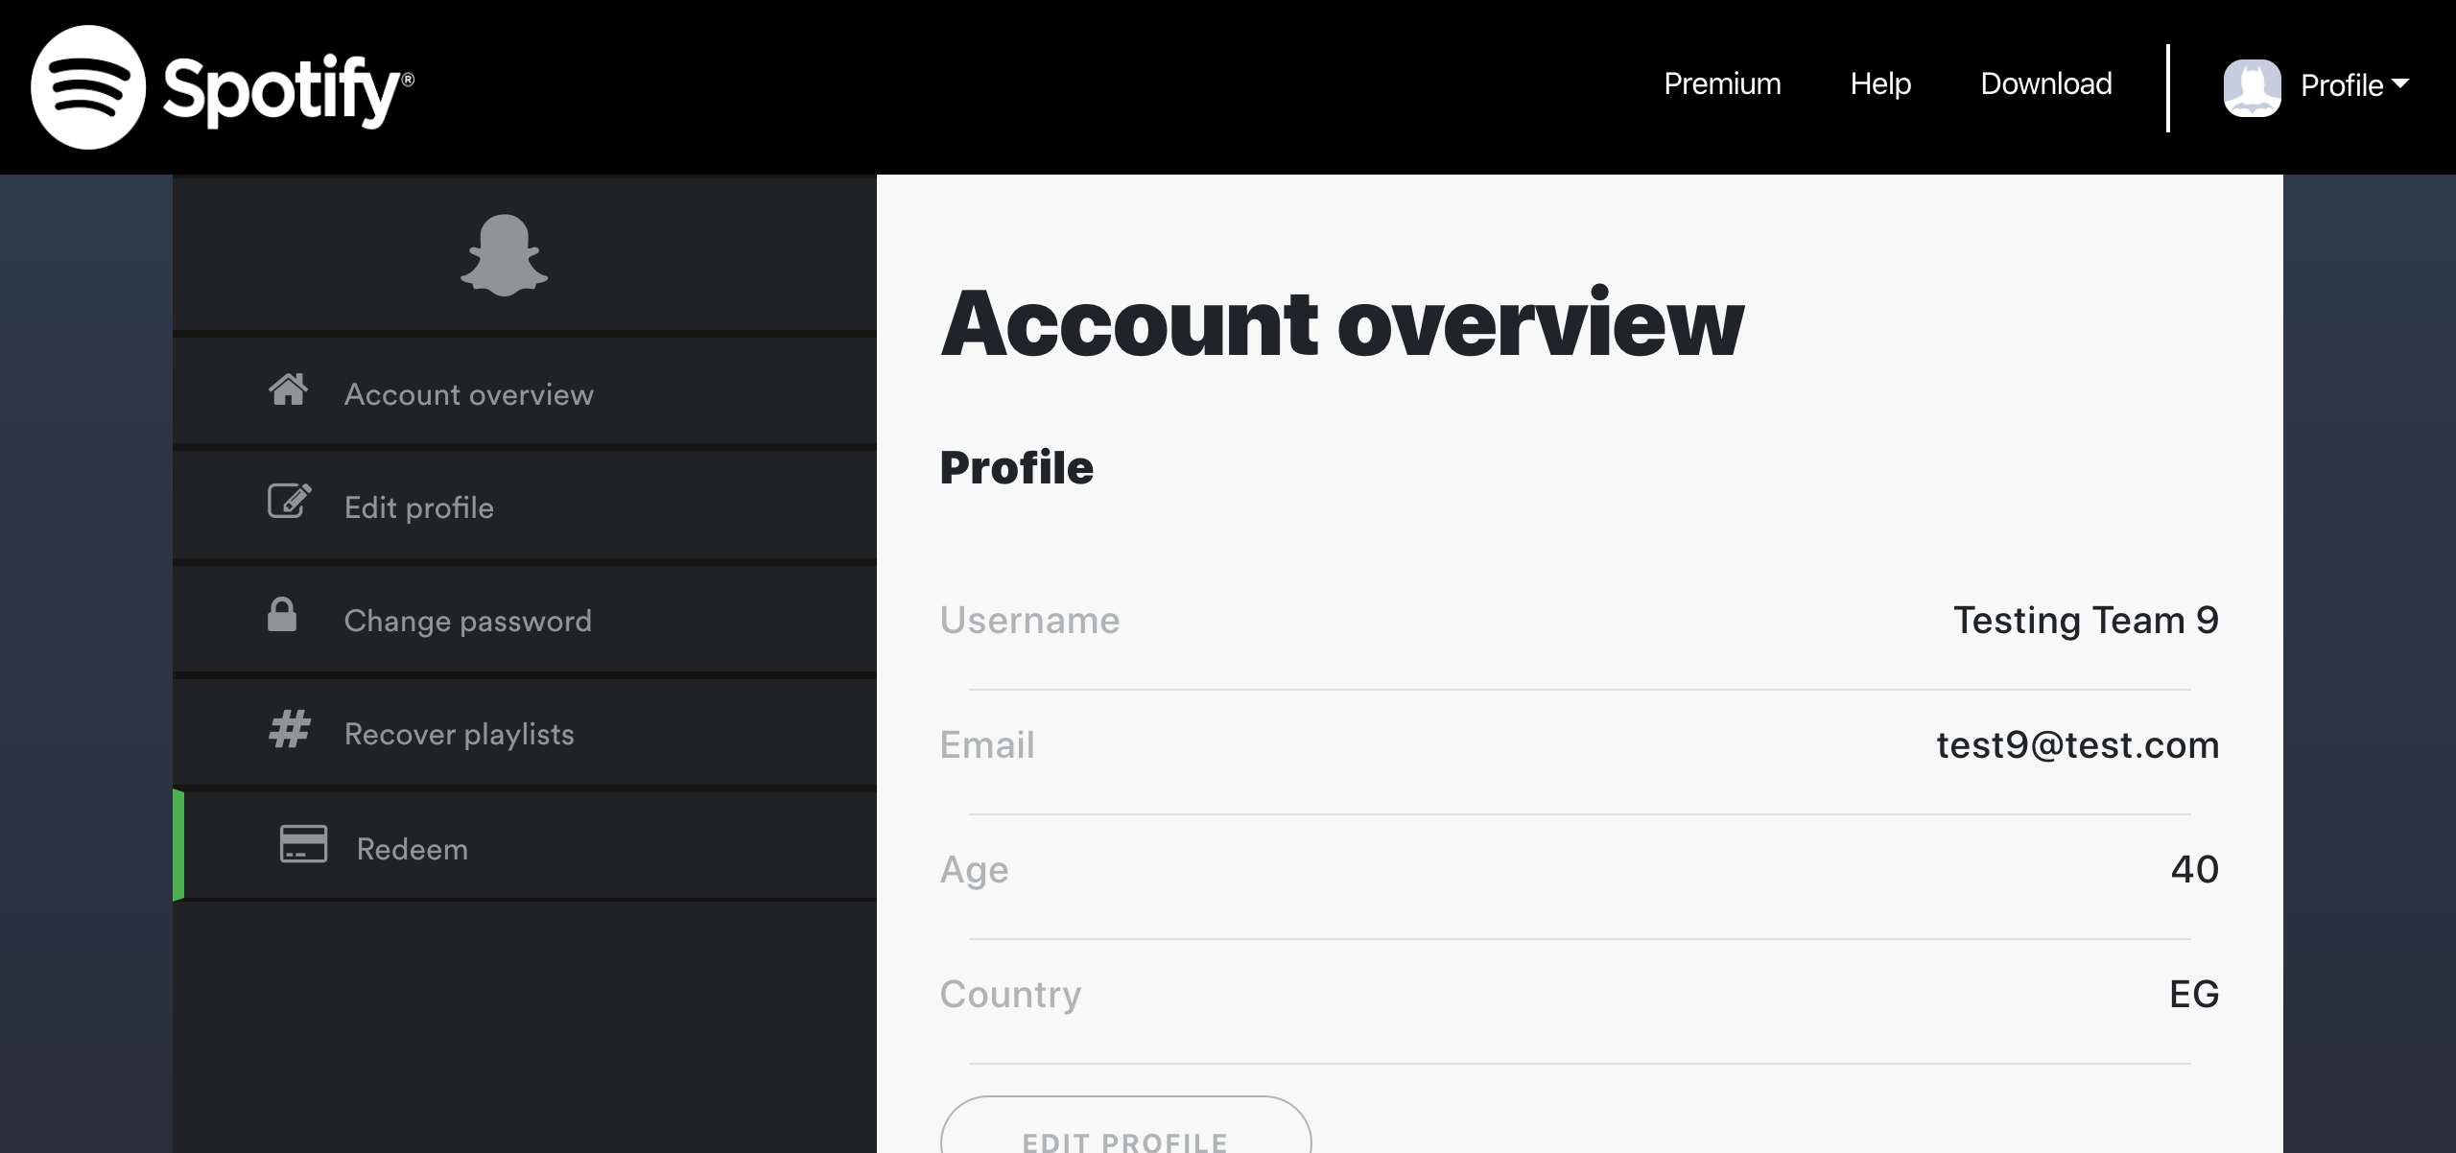

## Test Teardown

[Fixture] setup::0

# Clicking sign out button - passed

Clicking sign out button

## Test Setup

[Fixture] setup_final

## Test Body

[Attachment] sign out button functional

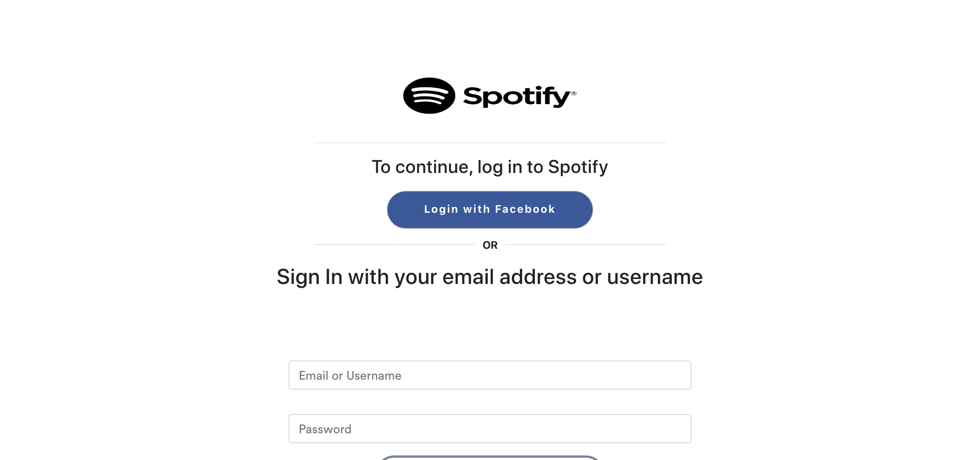

## Test Teardown

[Fixture] setup_final::0

# Invalid age test - passed

Testing with entering invalid age values

## Test Setup

[Fixture] setup_final

## Test Body

[Attachment] SUCCESS: Sign up stopped with invalid age values

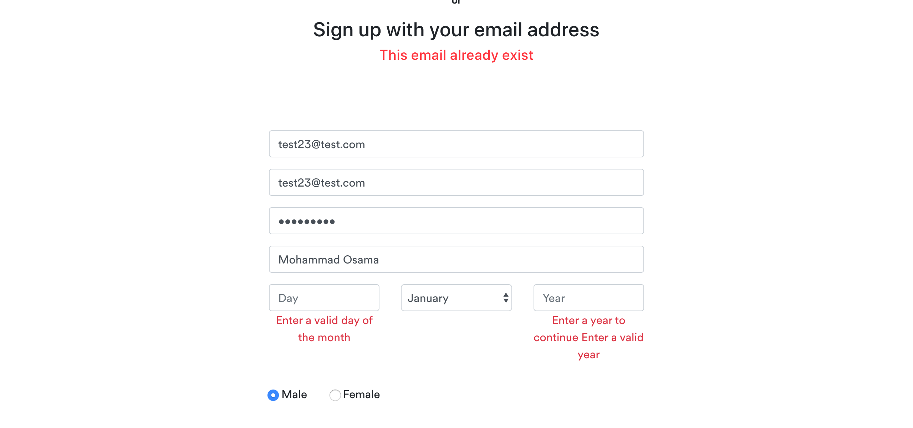

[Attachment] stdout

## Test Teardown

[Fixture] setup_final::0

# Liked Songs Button - passed

Testing Liked Songs Button

## Test Setup

[Fixture] setup

## Test Body

[Attachment] SUCCESS: Liked Songs button is functional

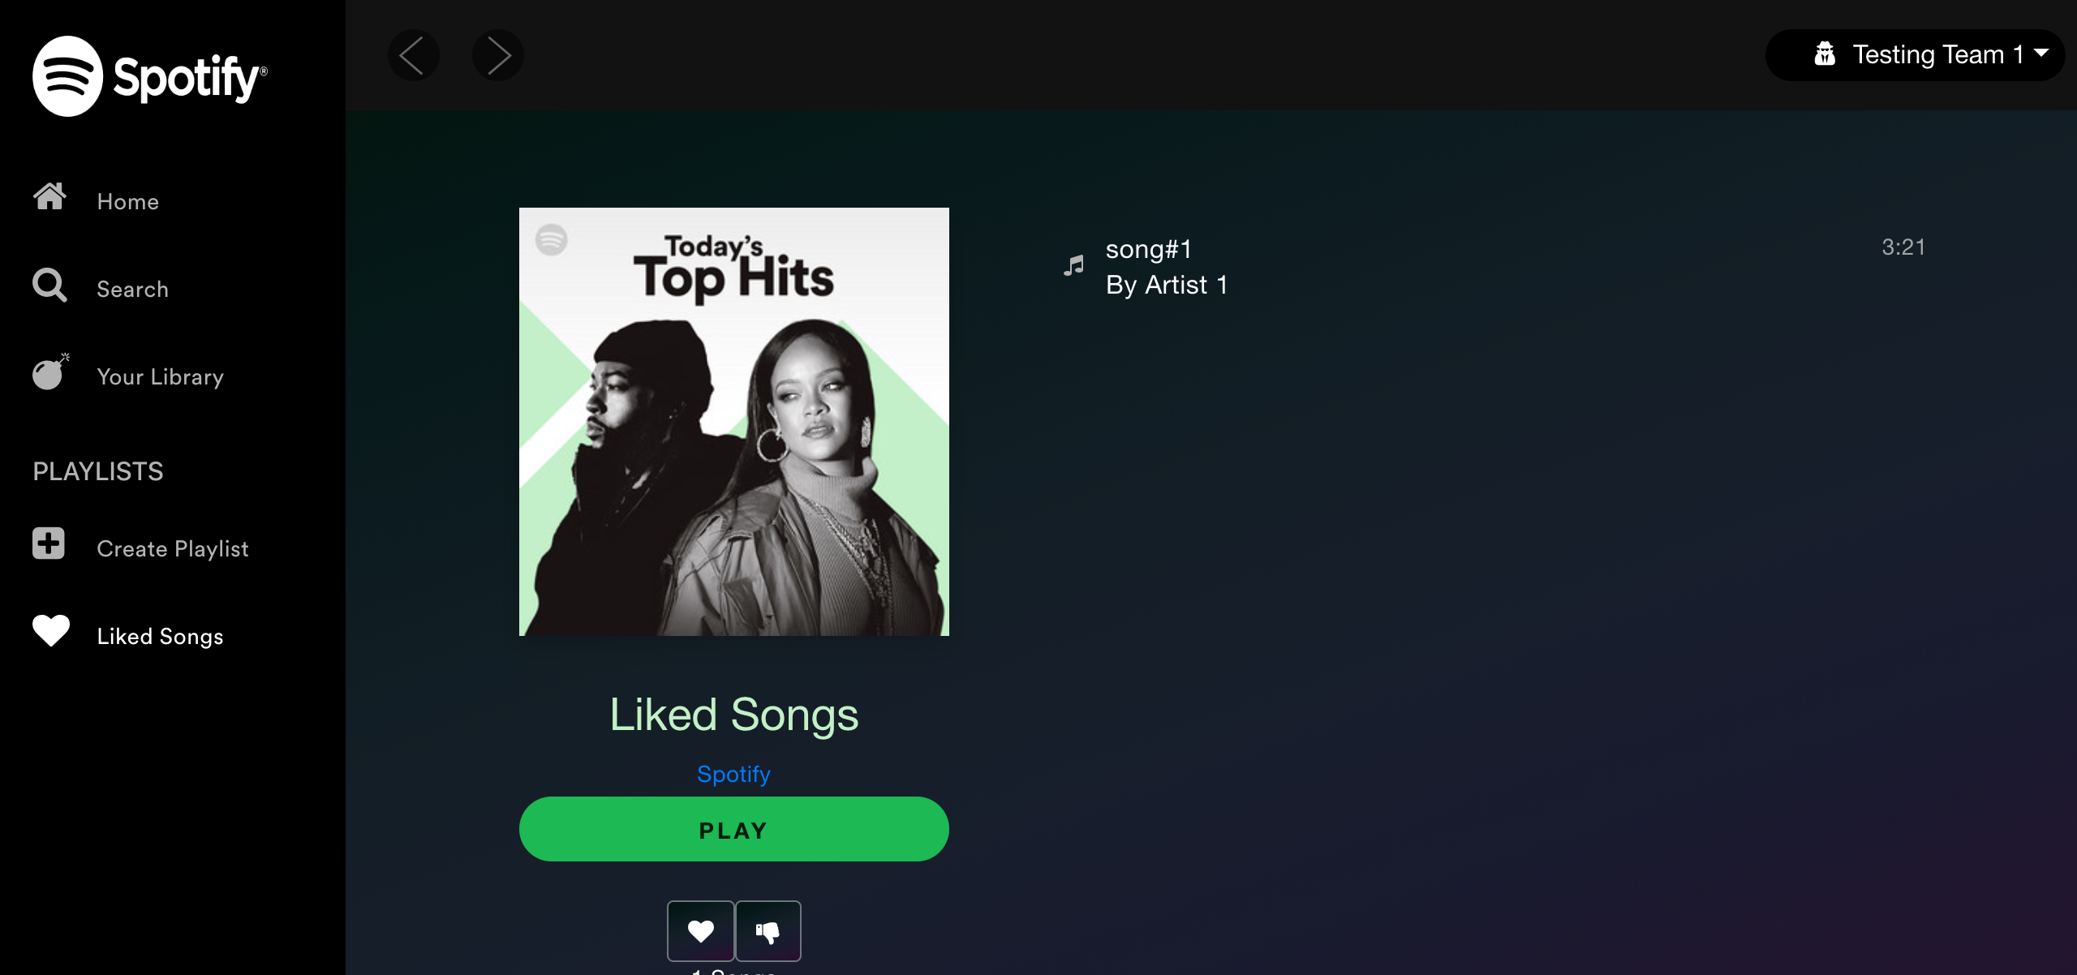

## Test Teardown

[Fixture] setup::0

# Liked Songs Play Button - passed

Testing Your Library Liked Songs Play Button

## Test Setup

[Fixture] setup_initial

## Test Body

[Attachment] SUCCESS: Your Library Liked songs cards are functional

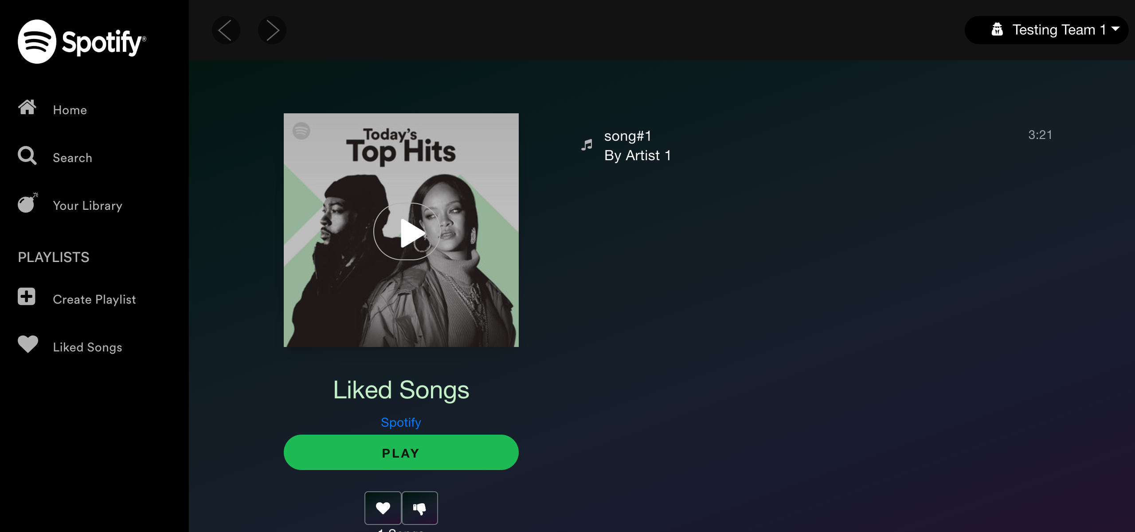

[Attachment] stdout

## Test Teardown

[Fixture] setup_initial::0

# Login with correct credentials - passed

Signing in with the following credentials email : test1@test.com & password: test123

## Test Setup

[Fixture] setup

## Test Body

[Attachment] SUCCESS: Login succeeded with correct credentials



[Attachment] stdout

## Test Teardown

[Fixture] setup::0

# Login with empty email - passed

Signing in with empty email

## Test Setup

[Fixture] setup

## Test Body

[Attachment] SUCCESS: Login failed with empty email

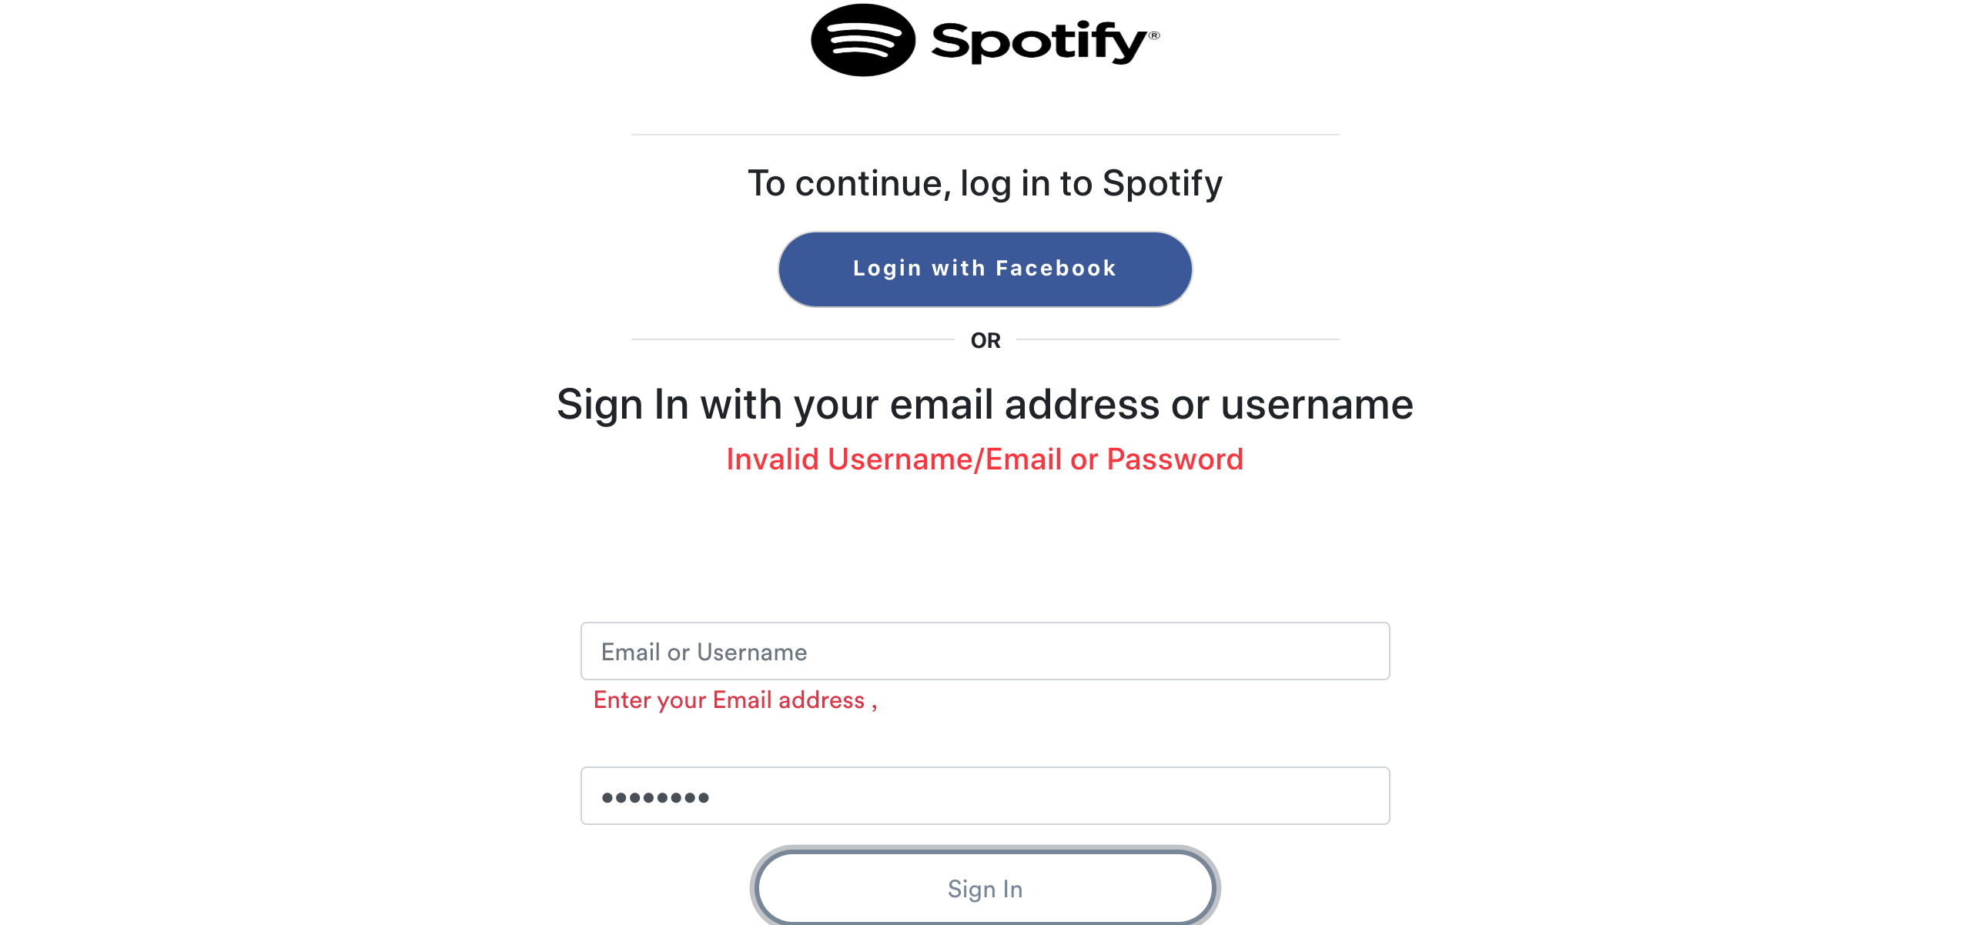

[Attachment] stdout

## Test Teardown

[Fixture] setup::0

# Login with empty email and password - passed

Signing in with empty email and password

## Test Setup

[Fixture] setup

## Test Body

[Attachment] SUCCESS: Login failed with empty email and password

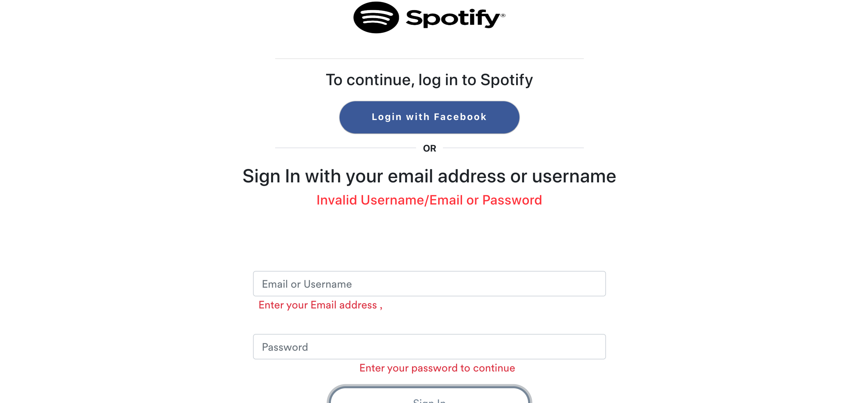

[Attachment] stdout

## Test Teardown

[Fixture] setup::0

# Login with empty password - passed

Signing in with empty password

## Test Setup

[Fixture] setup

## Test Body

[Attachment] SUCCESS: Login failed with empty password

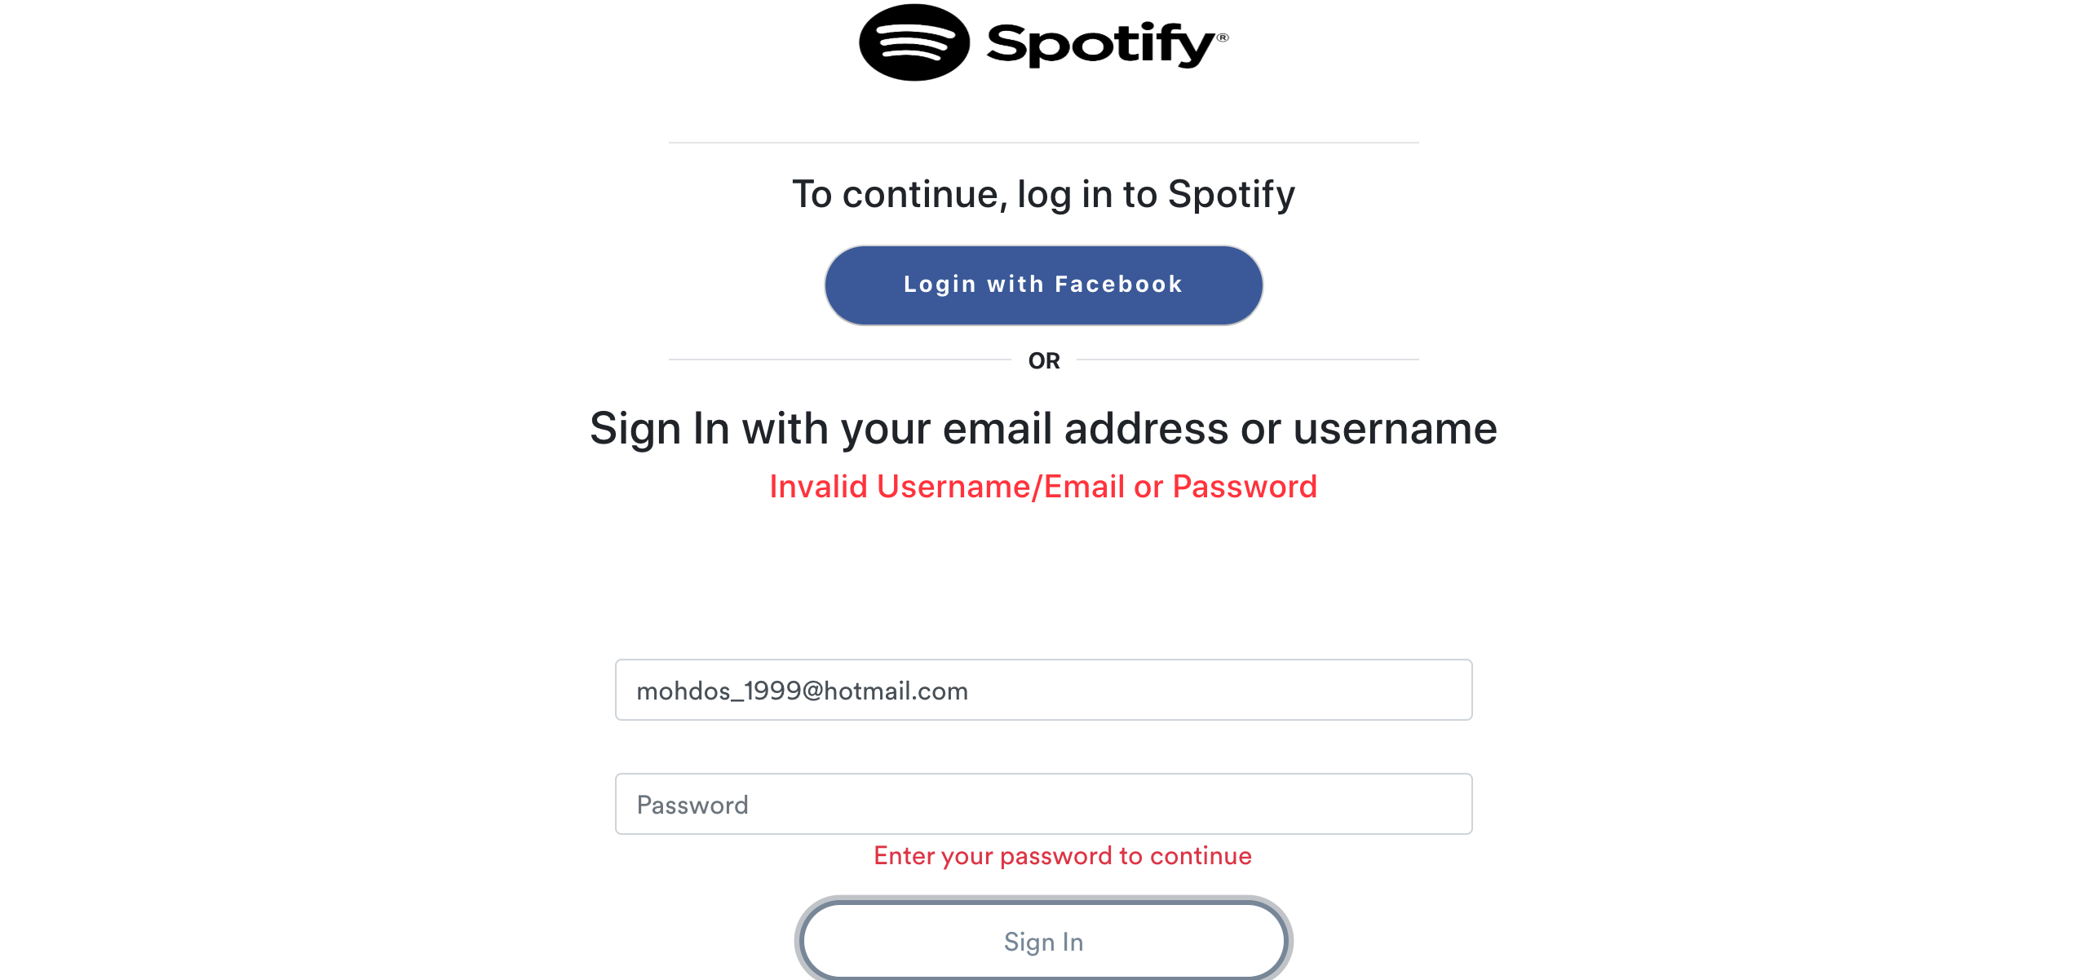

[Attachment] stdout

## Test Teardown

[Fixture] setup::0

# Login with wrong email - passed

Signing in with the following credentials email : kamelmohsenkamel & password: Kimo2010

## Test Setup

[Fixture] setup

## Test Body

[Attachment] SUCCESS: Login failed with incorrect credentials

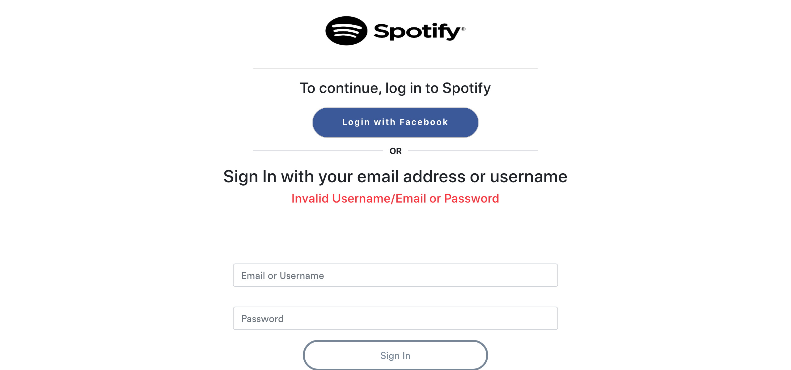

[Attachment] stdout

## Test Teardown

[Fixture] setup::0

# Login with wrong password - passed

Signing in with the following credentials email : kamelmohsenkamel@gmail.com & password: wrong password

## Test Setup

[Fixture] setup

## Test Body

[Attachment] SUCCESS: Login failed with incorrect credentials

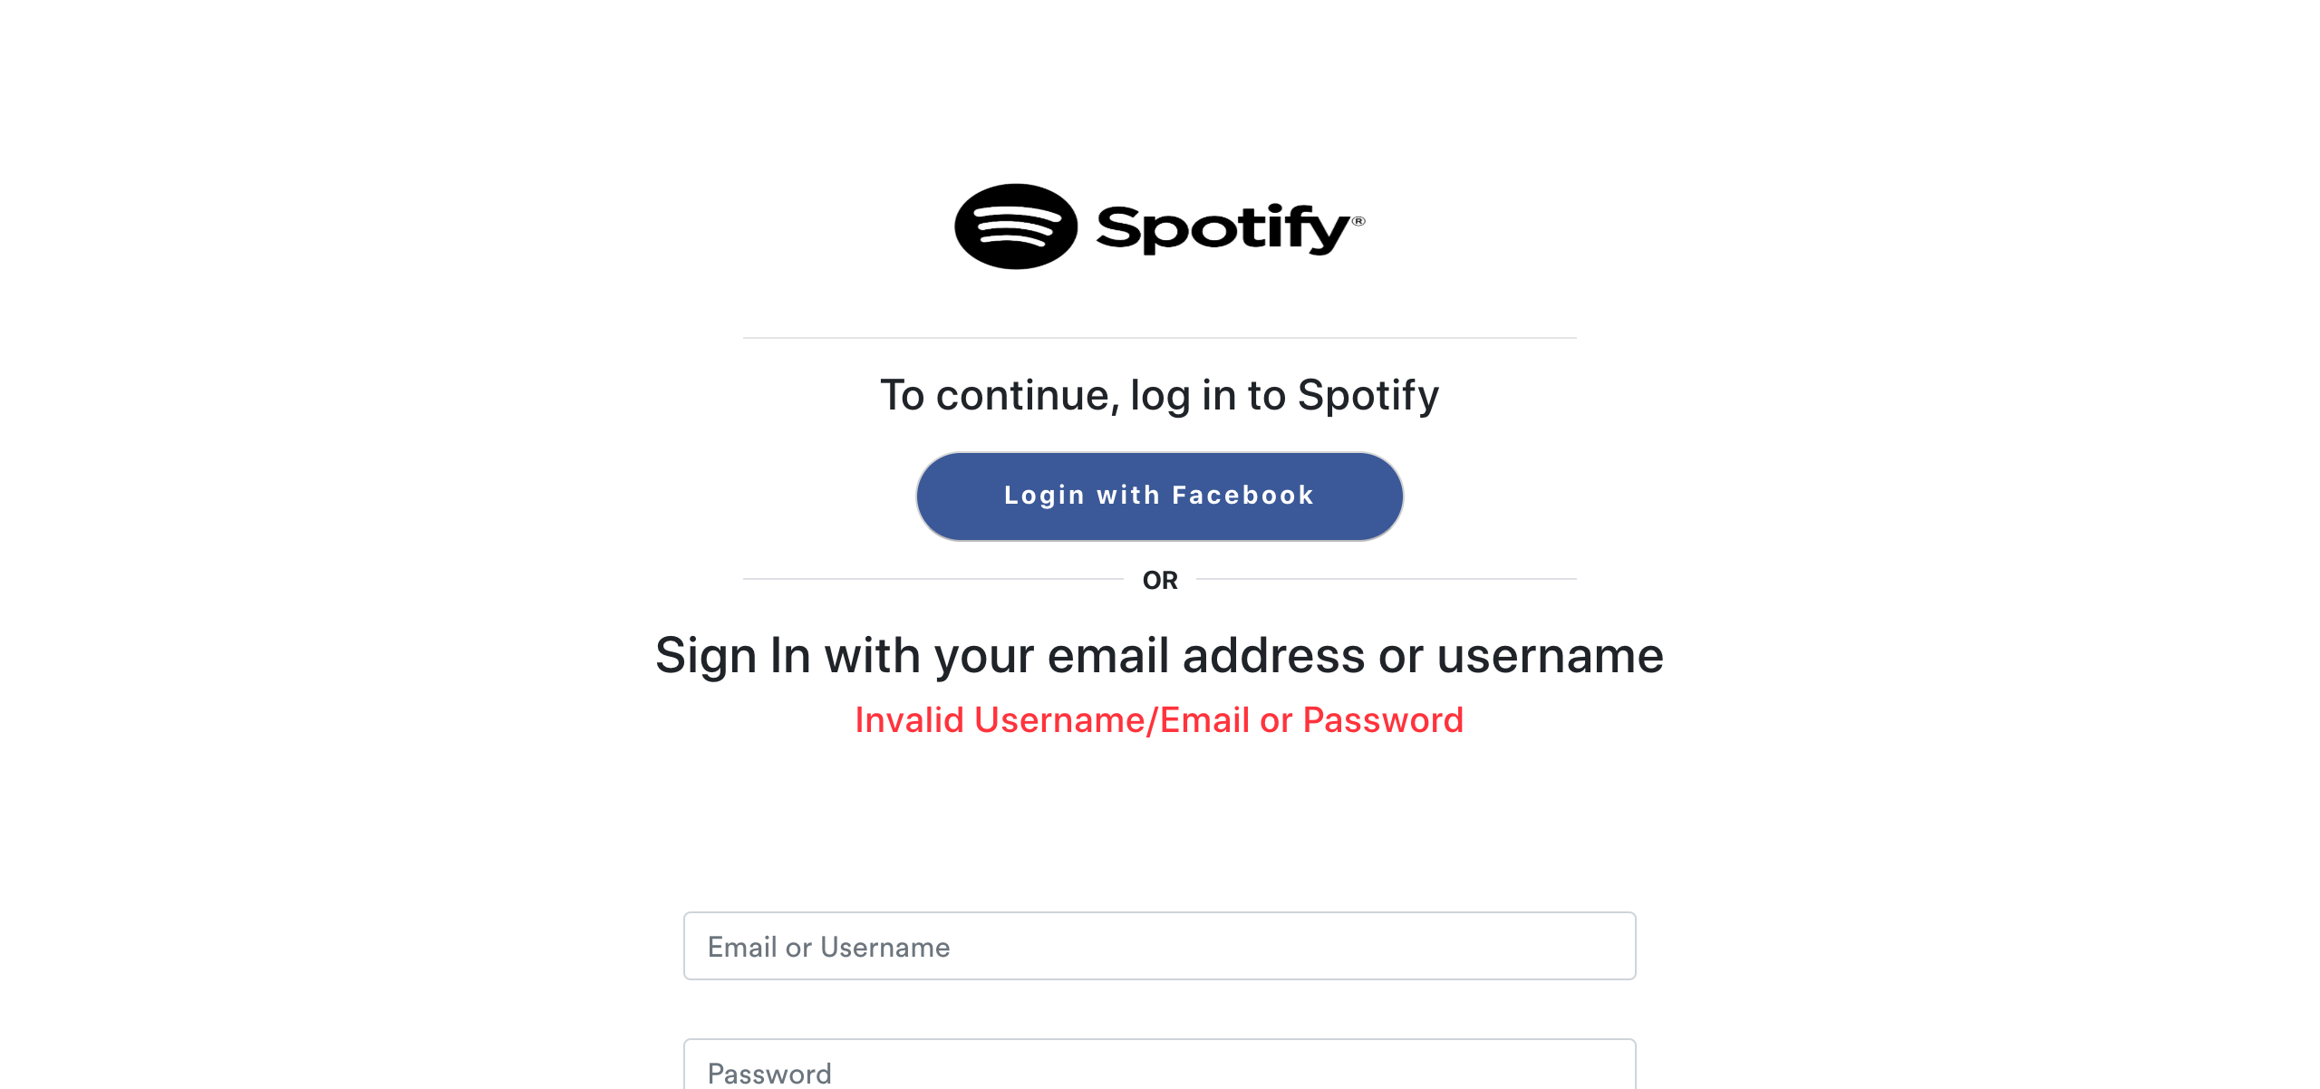

[Attachment] stdout

## Test Teardown

[Fixture] setup::0

# Logout button - passed

Testing Logout button

## Test Setup

[Fixture] setup

## Test Body

[Attachment] SUCCESS: Sign out button is functional

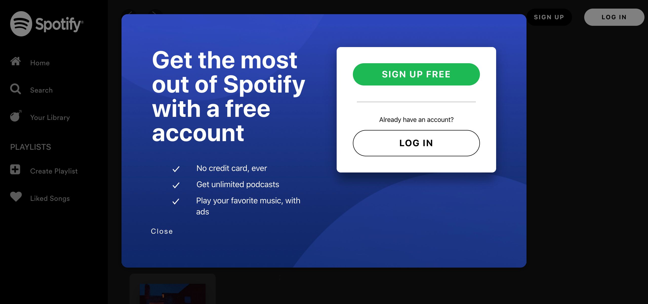

## Test Teardown

[Fixture] setup::0

# Playlists cards - passed

Testing Your Library Playlists cards

## Test Setup

[Fixture] setup

## Test Body

[Attachment] ERROR: Playlist name is not the same as the card name. Card name = Playlist 3  
Playlist, Playlist name = Playlist 3

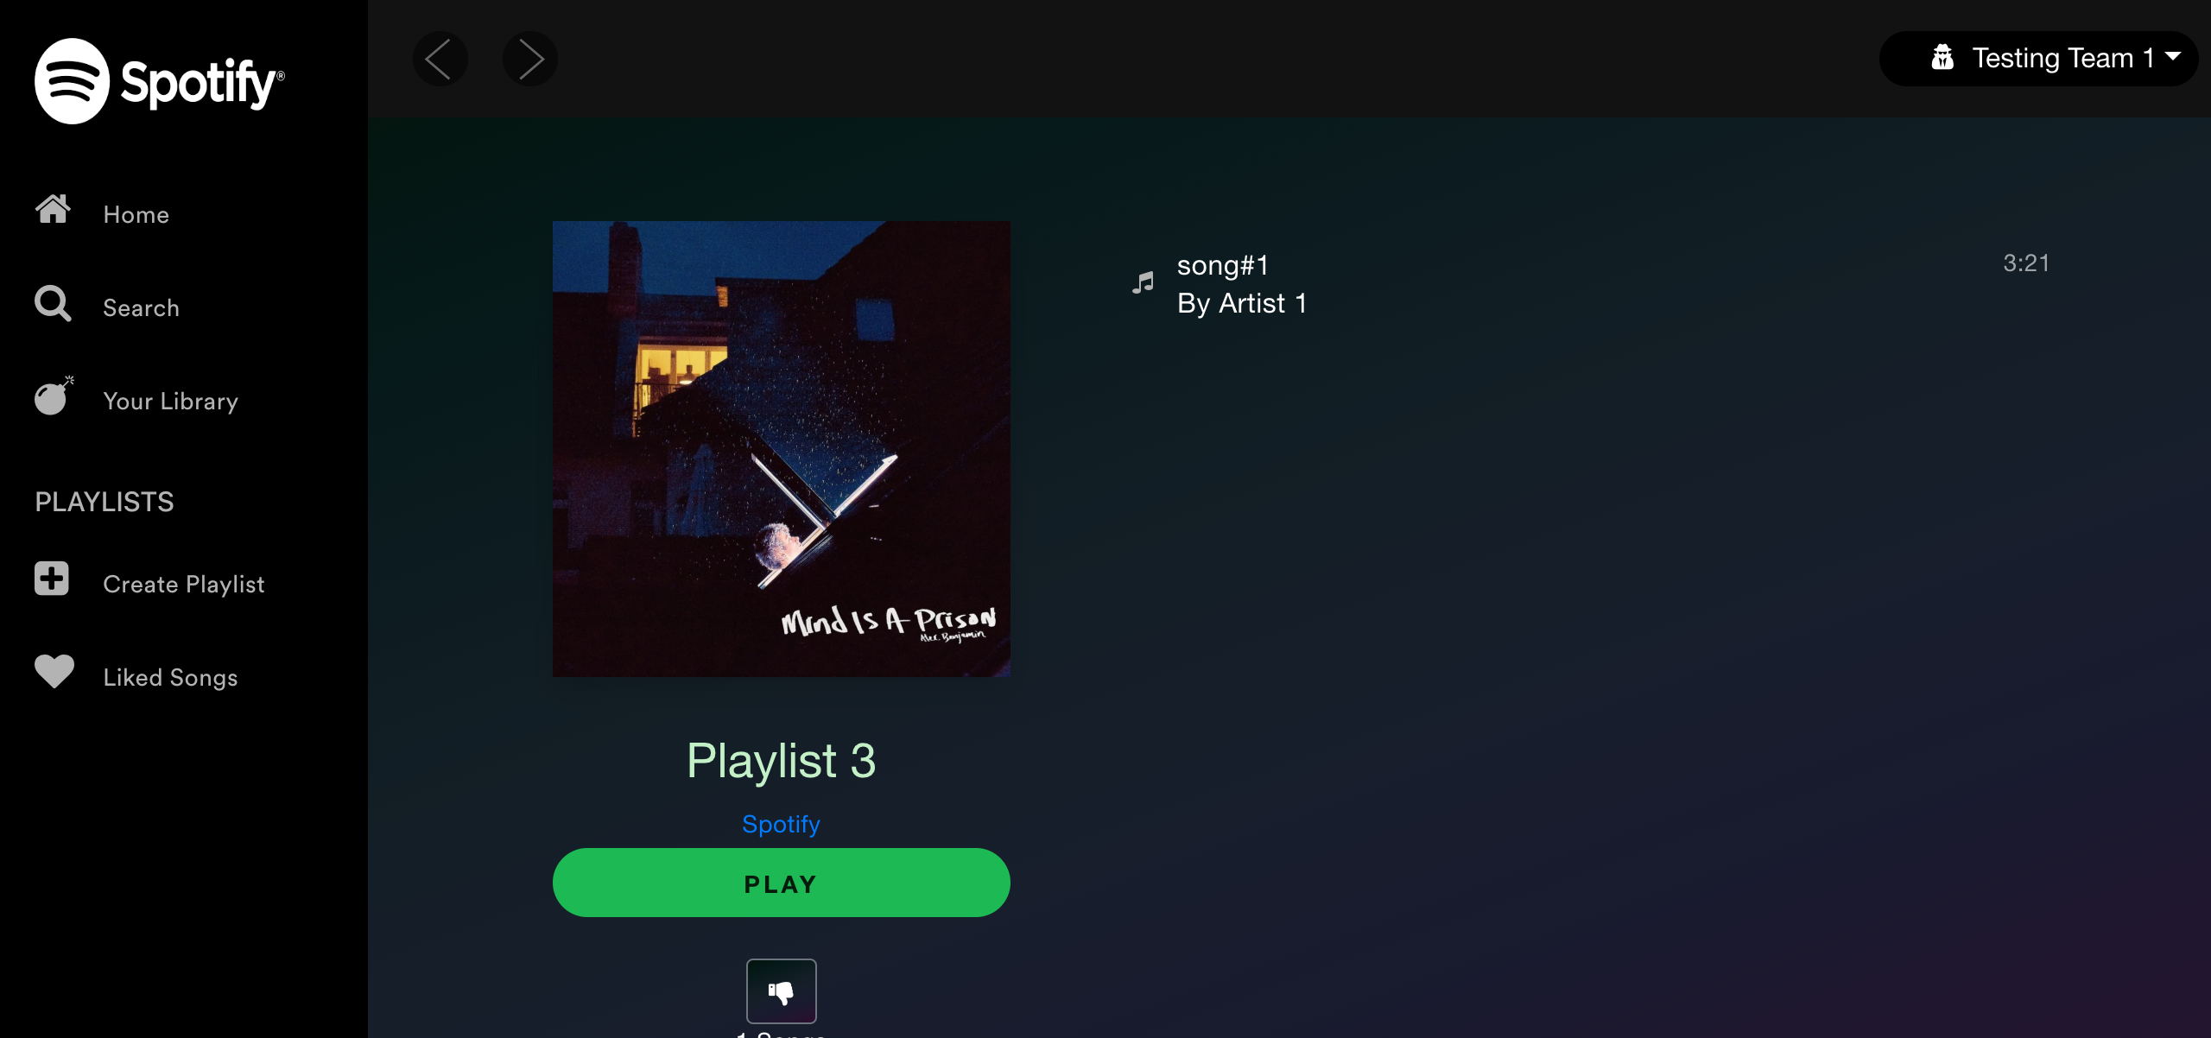

[Attachment] SUCCESS: Your Library page playlist cards are functional



## Test Teardown

[Fixture] setup::0

# Refresh Page - passed

Testing Refresh and make sure that elements are visible

## Test Setup

[Fixture] setup

## Test Body

[Attachment] SUCCESS: Elements are still visible after refresh

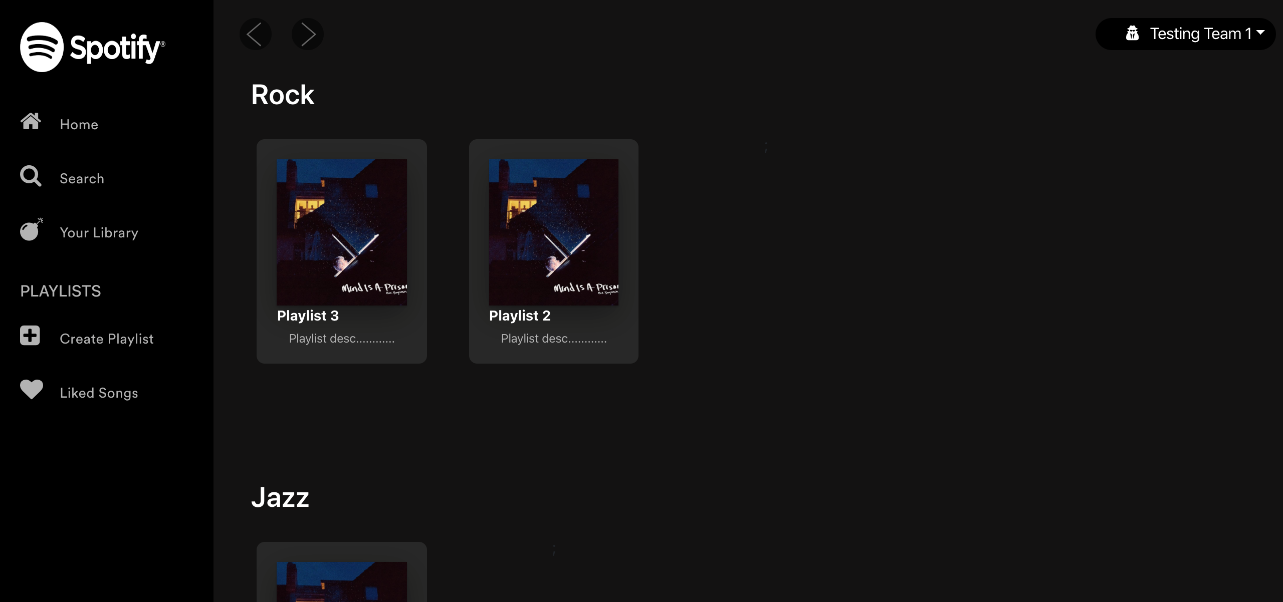

## Test Teardown

[Fixture] setup::0

# Signup with already registered email - passed

Signing up with the following credentials email: test_projectX@hotmail.com

## Test Setup

[Fixture] setup

## Test Body

[Attachment] SUCCESS: Sign up stopped with already registered email

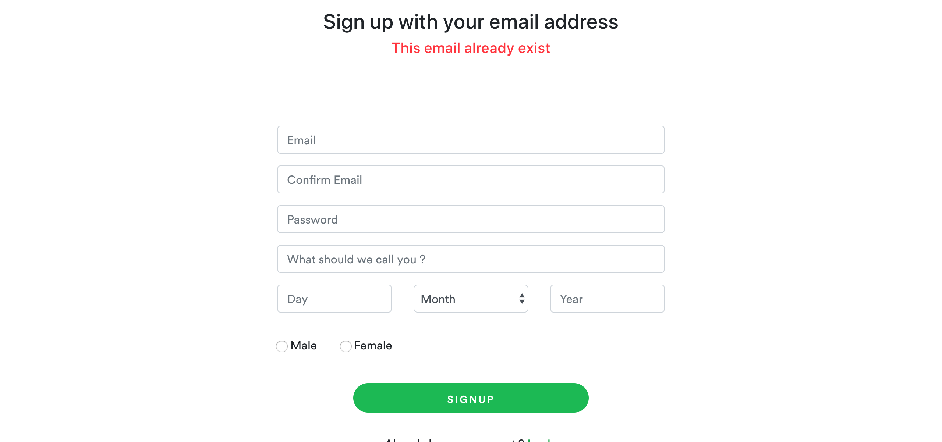

[Attachment] stdout

## Test Teardown

[Fixture] setup::0

# Signup with empty confirmation email - passed

Signing up with empty confirmation email

## Test Setup

[Fixture] setup

## Test Body

[Attachment] SUCCESS: Sign up stopped with empty confirmation email

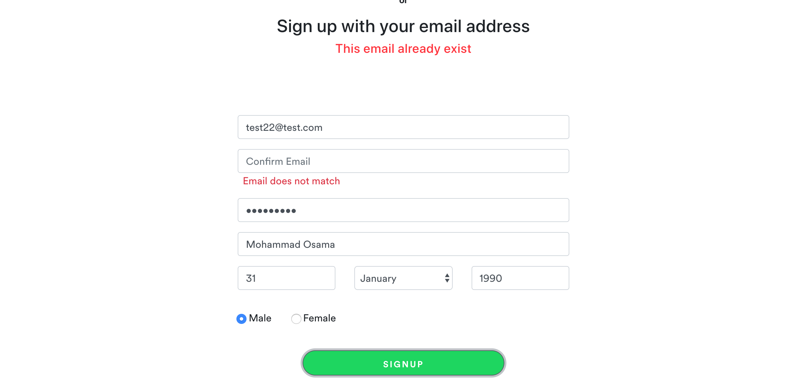

[Attachment] stdout

## Test Teardown

[Fixture] setup::0

# Signup with empty email - passed

Signing up with empty email

## Test Setup

[Fixture] setup

## Test Body

[Attachment] SUCCESS: Sign up stopped with empty email

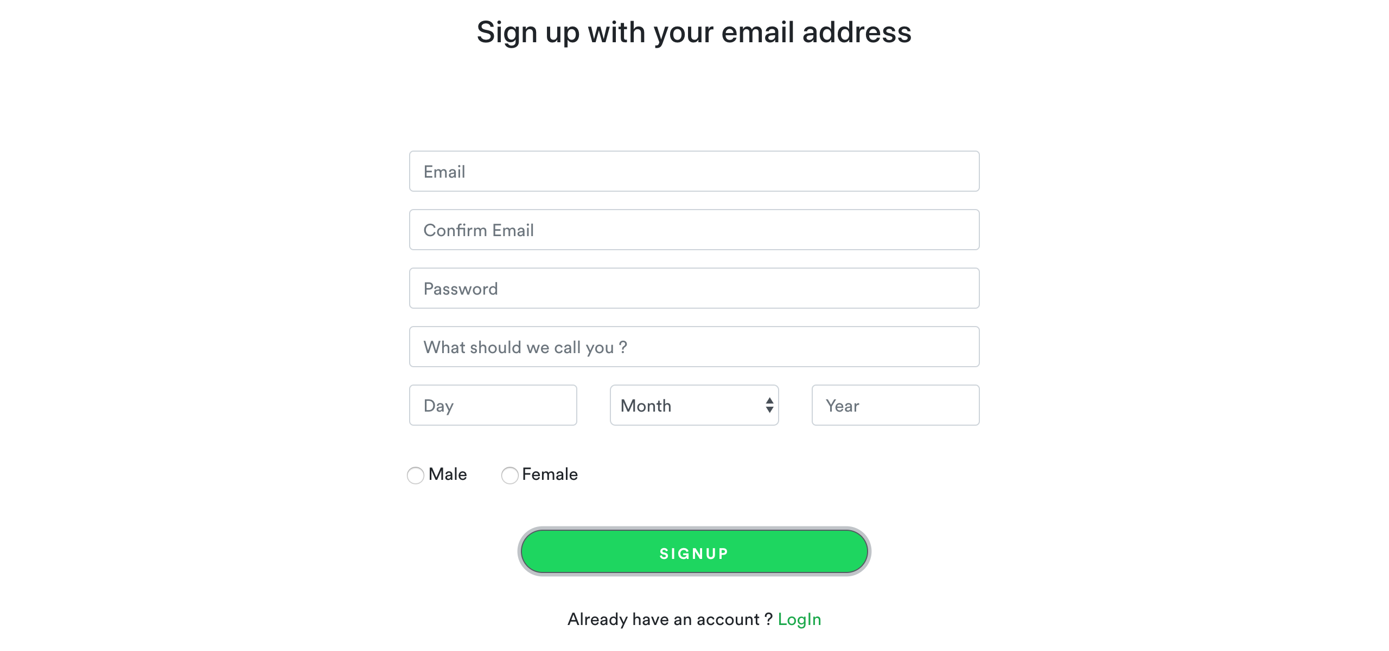

[Attachment] stdout

## Test Teardown

[Fixture] setup::0

# Signup with empty password - passed

Signing up with empty password

## Test Setup

[Fixture] setup

## Test Body

[Attachment] SUCCESS: Sign up stopped with empty password

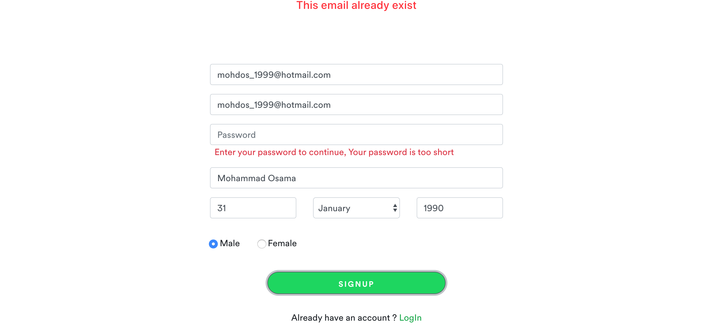

[Attachment] stdout

## Test Teardown

[Fixture] setup::0

# Signup with unselected day - passed

Signing up with unselected day

## Test Setup

[Fixture] setup

## Test Body

[Attachment] SUCCESS: Sign up stopped with unselected day

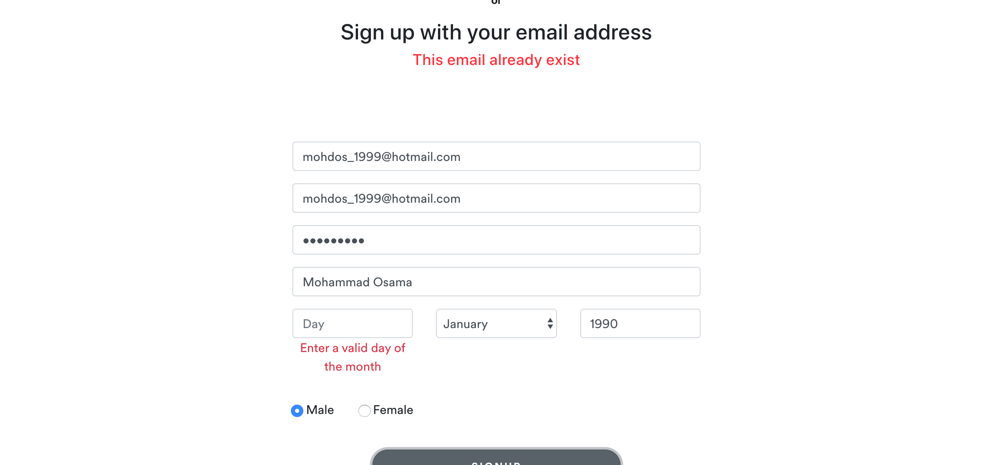

[Attachment] stdout

## Test Teardown

[Fixture] setup::0

# Signup with unselected gender - passed

Signing up with unselected gender

## Test Setup

[Fixture] setup

## Test Body

[Attachment] SUCCESS: Sign up stopped with unselected gender

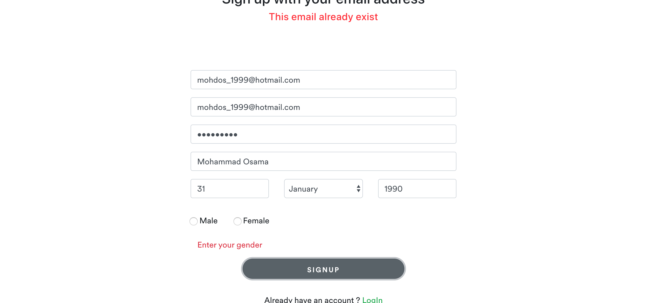

[Attachment] stdout

## Test Teardown

[Fixture] setup::0

# Signup with unselected month - passed

Signing up with unselected month

## Test Setup

[Fixture] setup

## Test Body

[Attachment] SUCCESS: Sign up stopped with unselected month

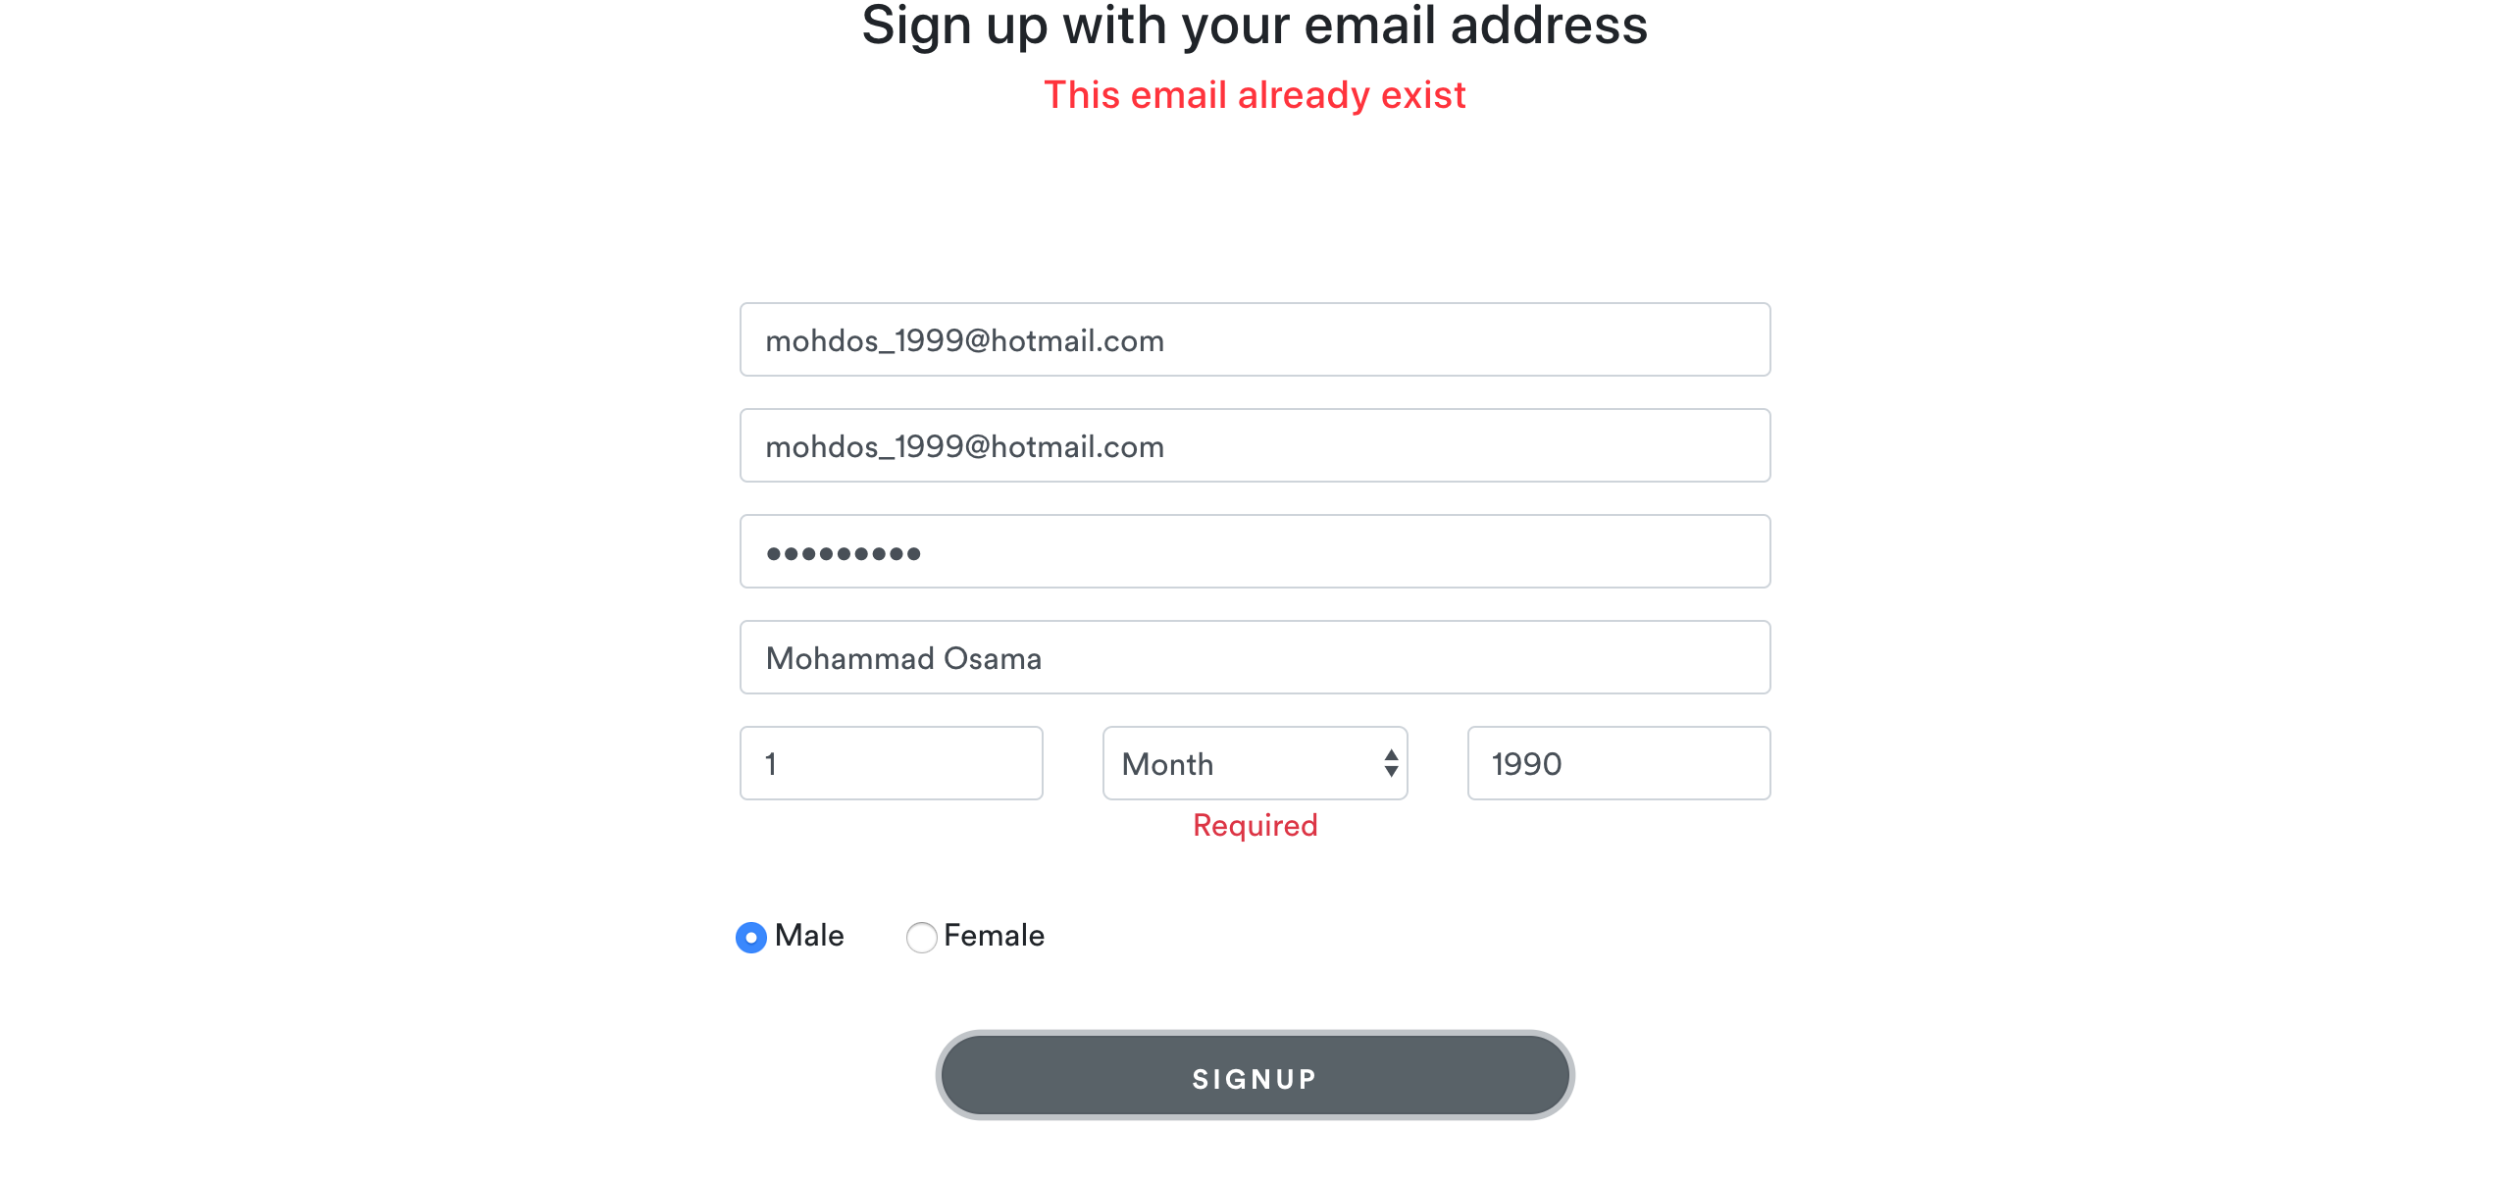

[Attachment] stdout

## Test Teardown

[Fixture] setup::0

# Signup with unselected year - passed

Signing up with unselected year

## Test Setup

[Fixture] setup

## Test Body

[Attachment] SUCCESS: Sign up stopped with unselected year

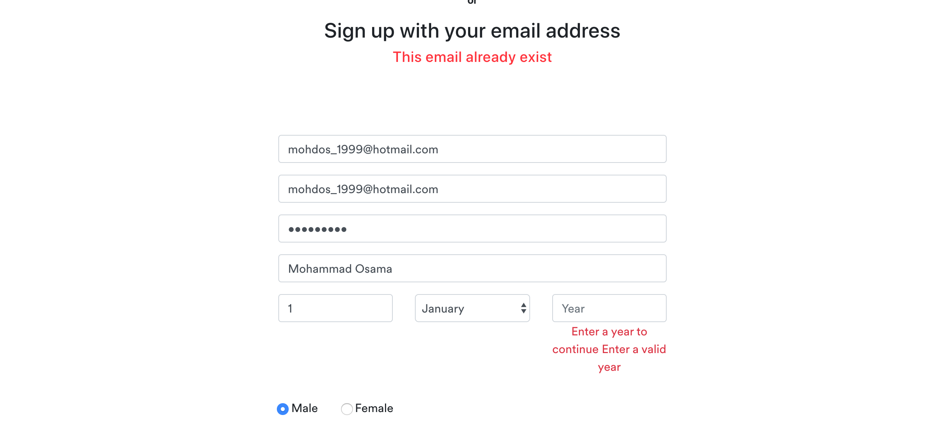

[Attachment] stdout

## Test Teardown

[Fixture] setup::0

# Spotify logo - passed

Spotify logo

## Test Setup

[Fixture] setup

## Test Body

[Attachment] Spotify logo functional

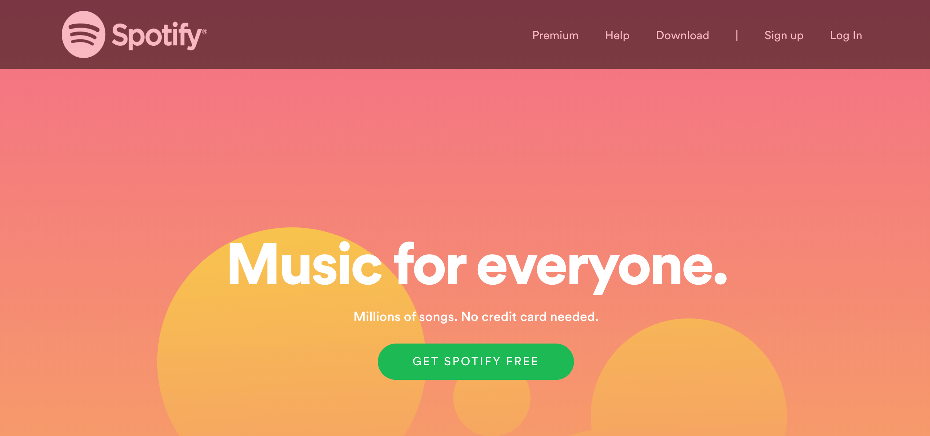

## Test Teardown

[Fixture] setup::0

# Testing Login Button - passed

Testing Login Button

## Test Setup

[Fixture] setup

## Test Body

[Attachment] Login button working

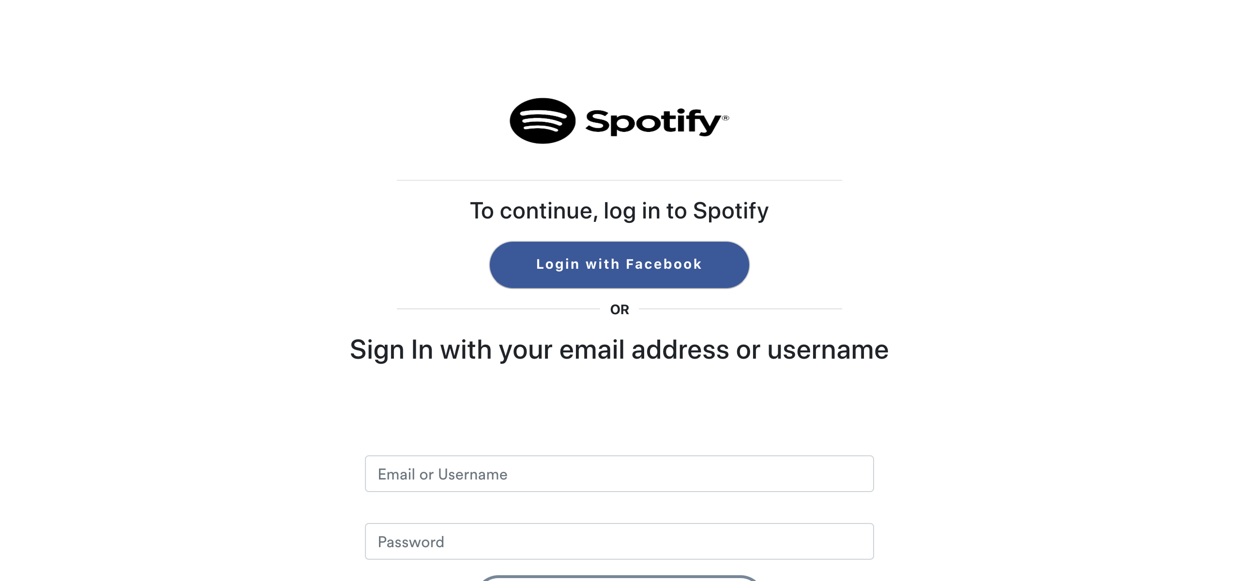

## Test Teardown

[Fixture] setup::0

# Testing Login button - passed

Testing Login button

## Test Setup

[Fixture] setup_final

## Test Body

[Attachment] SUCCESS: Login button is functional



## Test Teardown

[Fixture] setup_final::0

# Testing Sign up Button - passed

Testing Sign up button

## Test Setup

[Fixture] setup

## Test Body

[Attachment] Signup button working



## Test Teardown

[Fixture] setup::0

# Testing Sign up button - passed

Testing Sign up button

## Test Setup

[Fixture] setup

## Test Body

[Attachment] SUCCESS: Sign up button is functional



## Test Teardown

[Fixture] setup::0

# Your Library Button - passed

Testing Your Library Button

## Test Setup

[Fixture] setup_initial

## Test Body

[Attachment] SUCCESS: Your Library button is functional

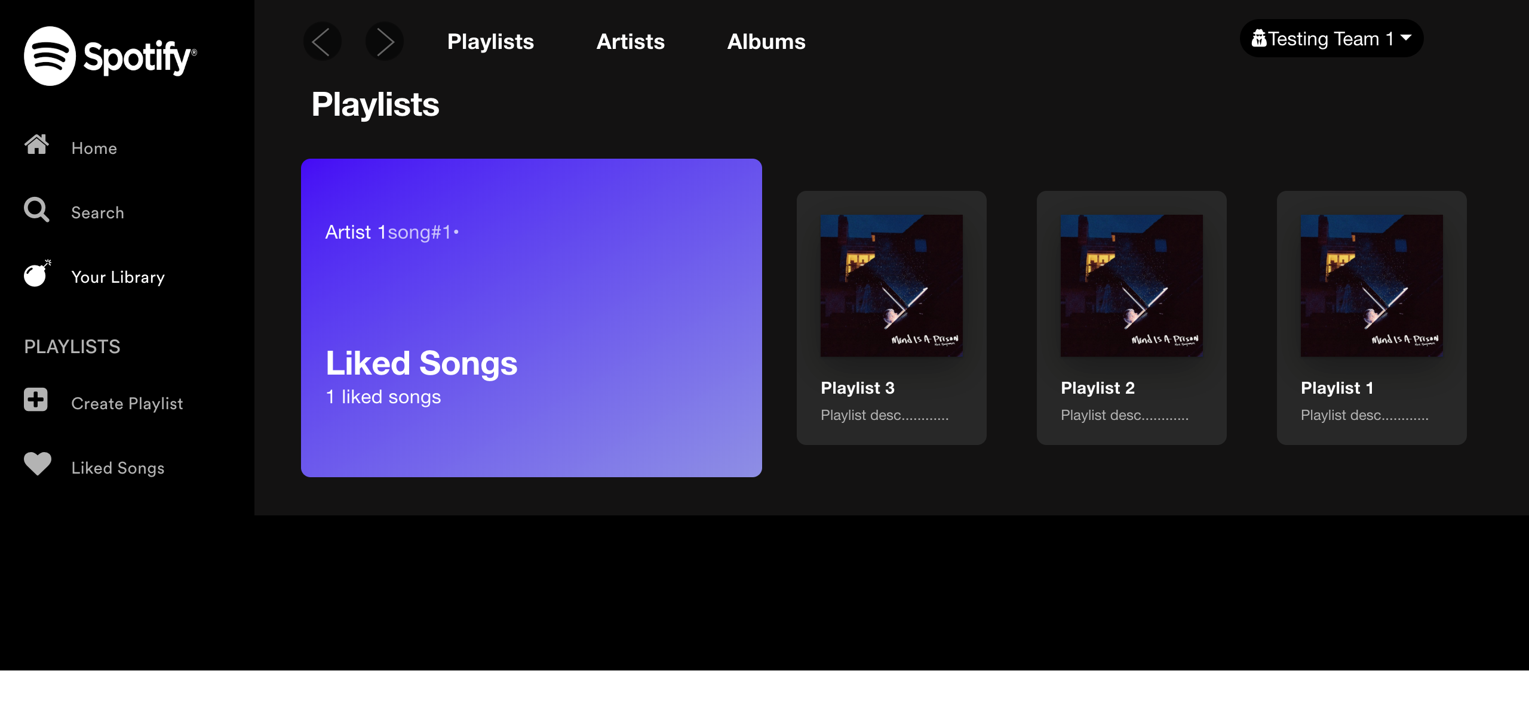

[Attachment] stdout

## Test Teardown

[Fixture] setup_initial::0